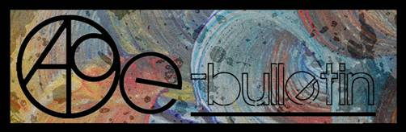

**Kilkenny County Council Arts Office- E-bulletin 16th May, 2014**

Dear All,   
  
Welcome to this week’s e-bulletin from Kilkenny County Council's Arts Office. Each bulletin is packed with the latest information on Kilkenny Arts Office activities, county events as well as news and opportunities for arts practitioners from around the country.

We have decided to shorten information included in the e-bulletin for easier use. This should particularly work well for those reading off tablets and smartphones.

This service will be provided fortnightly. To include an item in the next e-bulletin please send a brief outline of your advert with relevant contact details, including any websites or pages with links to [julianne.morgan@kilkennycoco.ie](mailto:julianne.morgan@kilkennycoco.ie) **before 28th May**. The next e-bulletin will be on **30th May**.

**PLEASE NOTE THE NEW EMAIL ADDRESS TO SEND INFORMATION FOR INCLUSION IN THE E-BULLETIN.**

While every effort has been made to ensure the accuracy of our information, we strongly advise readers to verify all details to their own satisfaction.

**It’s come to our attention that emails from Niamh Finn, Arts Administrator, may be going to your Spam. Niamh has changed her surname after marriage so please note her new email address is** [**niamh.brophy@kilkennycoco.ie**](mailto:niamh.brophy@kilkennycoco.ie)**and add it to your safe list and contacts for future reference.**

Regards,  
Julianne Morgan  
Arts Office  
T: 056 7794938  
E: [Julianne.Morgan@kilkennycoco.ie](mailto:Julianne.Morgan@kilkennycoco.ie)   
W: [www.kilkennycoco.ie/eng/Services/Arts/](http://www.kilkennycoco.ie/eng/Services/Arts/)  
Kilkenny County Council Arts Office Partner Local Authority of the ArtLinks Programme [www.artlinks.ie](http://www.artlinks.ie)

**___________________________________________________________________________**

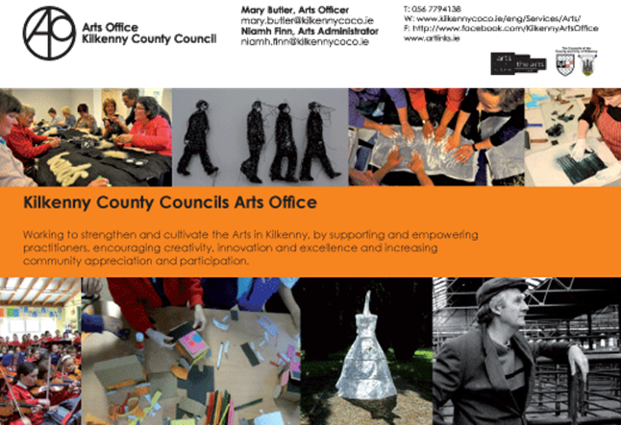

**___________________________________________________________________________**

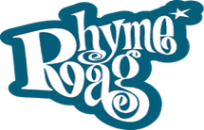                     

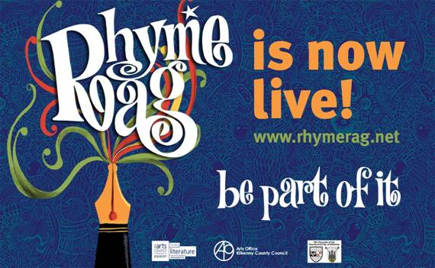

The Rhyme Rag is a poetry publication featuring the work of young Kilkenny writers and was initiated in 2005. Poems were submitted, poems were read, poems were selected by an editor, and then these selected poems were skilfully and wonderfully illustrated by our resident illustrator. We proceeded to produce an annual series of magnificent unique and distinctive comic style paperback poetry publications. Each issue has been full of emotion - pain, joy, sorrow, anger, frustration, humour and hilarity. Each issue has also been filled with quality writing, excellent poetry year on year... Basically this project went from strength to strength in a very short space of time. It was a hugely successful publication.

In 2010, the future of the Rhyme Rag was assessed as the Arts Officer felt that the model did not fully utilise the skills and interests of our participants, i.e. I felt we needed to communicate online... via social networking sites.

And here we have it, the new model this will maintain all of the creativity, the expression, the production of new work and the presentation of this work.

The work will be submitted and the editor will read and give feedback to a selection of poets. The editor will also select particular poems, two per month, to be published on the site. These poems will be professionally illustrated. Over the years and months we will build a community of workers and poems. The site will grow and grow over the years and the words, the pictures, the emotions and expression will ooze from this website.....

The programme will be complemented by school and library poetry workshops and residencies.

**BECOME PART OF IT, SUBMIT A POEM.....**<www.rhymerag.net>

Should you have any questions or require and further details please do not hesitate to contact me on 056 7794138 / [mary.butler@kilkennycoco.ie](mailto:mary.butler@kilkennycoco.ie)

Mary Butler, Arts Officer.

            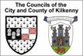           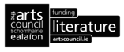

**___________________________________________________________________________**

# Short Story Workshop with Margaret Irish

# Short Story Workshop with Margaret Irish



As part of our on-going commitment to Kilkenny writers, Kilkenny County Council Arts Office would like to announce a Short Story Workshop with Kilkenny based writer Margaret Irish.

This one-day workshop will explore the craft of short story writing. The basics of how stories work, and the key issue of knowing the rules and knowing when to break them will be discussed. Suitable for new and experienced story writers, the workshop will:

- Consider what makes a short story, the many different types, and what we appreciate in a good one.  
- Discuss the role of character, plot and dialogue.  
- Explore a range of starting points - an image, a character, a place, an interior monologue.  
- Look at what happens next - ways to develop the story, considering different lengths and styles.  
- Discuss how structure emerges, the benefit of having an outline plan but letting the story lead you, and finding the right ending.  
- Provide guidelines on editing your story, the drafting process, and how to give and receive feedback.

Dates: This workshop will be run twice in the month of May on **Saturday 24th** and **Friday 30th May.**  
Venue: St. Mary's Day Care Centre, Gaol Rd, Haughney Green, Kilkenny (behind Omniplex Cinema)

Times: 10am- 12pm writing session, 12pm - 2pm lunch and networking session, 2pm - 4pm writing session.

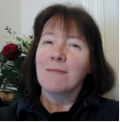

**Biography:** Margaret Irish's short fiction has been published in Ireland, the UK, Canada, and broadcast on RTE and BBC radio. Two radio plays have been produced by RTE, including a PJ O'Connor Award winner. Her stage play Ravine has had a public reading by Accidental Theatre Productions, Belfast. Her most recent story is included in the Dark Mountain anthology, published in the UK in April.

Places are limited to 15 participants per day so please book early to secure your place. These workshops are open to Kilkenny writers only. A nominal fee of **€15 / €10** concession that is non-refundable should a participant cancel applies.

To secure a place please select which date you wish to attend, **Saturday 24th** or **Friday 30th May**, and contact the Arts Office on 056 7794138 or email [niamh.brophy@kilkennycoco.ie](mailto:niamh.brophy@kilkennycoco.ie). Places are secured on a first come first served basis.

**Deadline for bookings and payment is Monday 19th May.**



**___________________________________________________________________________**

# Kilkenny Arts Office Irish Youth Choir Summer School Bursary 2014

# Kilkenny Arts Office Irish Youth Choir Summer School Bursary 2014



The Association of Irish Choirs is pleased to partner with Kilkenny County Council's Arts Office, to offer a bursary to attend the Irish Youth Choir Summer School, taking place from 29th June to 7th July. This bursary is open to singers aged between 18 and 28 with relevant choral experience, who live within Kilkenny County Council's administrative area. Selection is via IYC's application form and audition, and candidates will be required to complete a short form for Kilkenny Arts Office should they fulfil the criteria.

**Closing date for the receipt of bursary applications is no later than 4pm on Friday 13th June 2014.**

Download your application here: [Irish Youth Choir Summer School Bursary Application Form 2014](http://www.kilkennycoco.ie/eng/Services/Arts/News/Irish-youth-choir-summer-school-bursary-application-form.doc)

For application forms regarding the bursary please contact:   
Niamh Brophy, Arts Administrator, Kilkenny County Council Arts Office, John's Green House, John's Green, Kilkenny.  
T: 056 779 4138 E: [niamh.brophy@kilkennycoco.ie](mailto:niamh.brophy@kilkennycoco.ie)

Or contact the Association of Irish Choir's (AOIC), Irish Youth Choir Summer School at: <http://www.aoic.ie/iyc/>

*************************************************

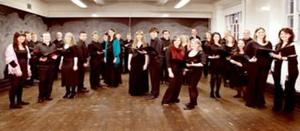

**AOIC's Irish Youth Choir Summer School Information**

Made up of Ireland's finest young singers aged 18 to 28, the Irish Youth Choir meets annually for a main intensive rehearsal course in the summer under the expert tuition of the Artistic Director, Greg Beardsell, and a team of tutors and vocal coaches. The week culminates in a number of performances in varying touring venues at the beginning of July and August. Delivered by the Association of Irish Choirs, the Irish Youth Choir Summer school 2014 is a residential week in the University of Limerick, running from 29th June- 7th July 2014. During the residency, singers undertake intensive training and professional development.

**When: 29th June to 7th July (inclusive)**

**Where:** University of Limerick

**Who is this suitable for?**  
Those aged between 18 and 28 on 28th June 2014 with relevant choral/singing experience, who wish to train with leading vocal and choral professionals during a week-long residential summer course.

**What's the damage?**  
The cost of attending the school is as follows:  
- Full board, Waged €499 Unwaged / student €459   
- Accommodation only, Waged €370 Unwaged / student €340   
- Food only, Waged €370 Unwaged / student €340   
- Tuition only, Waged €260 Unwaged / student €240

**Where do I sign up?**  
Download the I.Y.C application form here: <http://www.aoic.ie/iyc/join_us/?gclid=CPir4oTEnL4CFcJ82wodRkkA5g>

**___________________________________________________________________________**

# Kilkenny Arts Office NYCI Summer School Bursary 2014

 Kilkenny Arts Office NYCI Summer School Bursary 2014



NYCI is pleased to partner Kilkenny County Council's Arts Office to offer a bursary to attend NYCI's Youth Arts Summer School. This bursary will be open to youth workers and volunteers, and arts practitioners working in youth contexts who live within Kilkenny County Council's administrative area. Application will be via NYCI's regular booking system, and candidates will be required to fill out a short form for Kilkenny Arts Office should they fulfil the criteria.

**Closing date for the receipt of submission for this bursary from Kilkenny Arts Office is no later than 4pm on Friday 23rd May 2014.**

For all application forms regarding the Bursary please contact:

Niamh Brophy, Arts Administrator, Kilkenny County Council Arts Office, John's Green House, John's Green, Kilkenny.  
T: 056 779 4138 E: [niamh.brophy@kilkennycoco.ie](mailto:niamh.brophy@kilkennycoco.ie)

OR download your application here: [Kilkenny Arts Office NYCI's Youth Arts Summer School Bursary Application Form 2014](http://www.kilkennycoco.ie/eng/Services/Arts/News/NYCI-summer-school-Application-Form-2014.doc)

**************************************

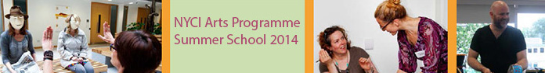

**NYCI's Youth Arts Summer School Information**

Delivered by NYCI's Youth Arts Programme, Summer School is a 3-day residential youth arts practice summer school in NUI Galway, running from 11th-13th June 2014. It will offer workshops, evening events and lots more to stimulate your imagination and send you home with a wealth of ideas and techniques for developing creative approaches for your work with young people.

**When: Wed 11th - Fri 13th June 2014**

**Where:** NUI Galway

The 3-day in-depth workshop experience will give you the inspiration, indepth practical know-how and skills to work in new ways with your young people and offer them high quality arts experiences.

**Who is this suitable for?**  
Anyone working with young people in the non formal education sector who wishes to explore ways of introducing, enhancing and extending youth arts provision for the young people with whom they work. It is aimed both at those looking to improve their art-form and delivery techniques or those totally new to youth arts.

**What's the damage?**  
The cost of attending summer school is highly subsidised by NYCI Arts Programme. It will cost 250 for members of NYCI and 300 for non members. This covers your accommodation, meals, all workshops and materials. In addition, we are offering an early bird promotion - if you book and pay before 16th May 2014, there will be an additional €50 discount. This brings the cost to €200 for members and €250  for non members.

**Where do I sign up?**  
<http://nycitraining.org/yass2014>

**___________________________________________________________________________**

**Exhibition ‘THE UNHAPPY ISLAND’, works by Saturio Alonso**

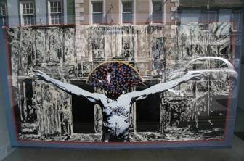

An exhibition by Saturio Alonso is now on display in the windows of Kilkenny Arts Office, no.76, John Street.

Images will change every few days/weeks.

**___________________________________________________________________________**



# ‘Just go for it’ - Submit your work to the Kilkenny Poetry Broadsheet 2014 – Closing Date Friday 23rd May

Kilkenny County Council Arts Office is delighted to announce a call for submissions for the publication of the fourteenth issue of the very popular **Kilkenny Poetry Broadsheet**. The aim of the publication is to give local writers a platform for their work. Each poem selected is included in the broadsheet which is available free throughout the County. One hundred and three poems were submitted for inclusion by forty one writers for the 2013 edition.

This fourteenth issue of Kilkenny Poetry Broadsheet will be edited by Enda Coyle-Greene.

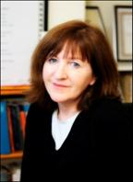    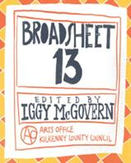

Enda Coyle-Greene lives in Co. Dublin. Published widely in print and online journals, she is also a frequent contributor to programmes on RTÉ Radio.

Her work featured in anthologies such as *Sunday Miscellany – a Selection from 2004 -2006* (2006), *The Echoing Years* – *An Anthology of Contemporary Poetry and Translation from Canada and Ireland* (2007), *The Quiet Quarter – Ten Years of Great Irish Writing,* (2009), *Shine On* – *Irish Writers for Shine* (2011) and, most recently, *If Ever You Go – A Map of Dublin in Poetry and Song*, the UNESCO City of Literature, Dublin: One City, One Book title for 2014.

Her first collection of poetry, *Snow Negatives,* won the Patrick Kavanagh Award in 2006 and was published by the Dedalus Press the following year. Her second collection, *Map of the Last*, also from Dedalus, was published in 2013.

We are accepting submissions from poets born or based in Kilkenny City and County.

Application forms and submission rules are available from the Arts Office, John’s Green house, John’s Green, Kilkenny. T: 056 7794138 E: [niamh.finn@kilkennycoco.ie](mailto:niamh.finn@kilkennycoco.ie) / [julianne.morgan@kilkennycoco.ie](mailto:julianne.morgan@kilkennycoco.ie)

Or can be downloaded from: [Kilkenny poetry broadsheet issue 14 application form](http://www.kilkennycoco.ie/eng/Services/Arts/News/2014-broadsheet-application.doc)

[Kilkenny poetry broadsheet issue 14 application form](http://www.kilkennycoco.ie/eng/Services/Arts/News/Broadsheet-2014-application-pdf.pdf)

No electronic submissions accepted.

**Closing date for receipt of submissions is no later than 4pm on Friday 23rd May.**

To coincide with the call for submissions for Kilkenny Poetry Broadsheet, this year's Editor, poet Enda Coyle-Greene, answers some questions on writing, reading, life, and shares her thoughts on Kilkenny Poetry Broadsheet. Read the full interview at [http://tinyurl.com/lvhfax4](http://tinyurl.com/lvhfax4%20)

**Ends.**

Images:  Enda Coyle-Greene and Broadsheet 2013

For further information or images please contact The Arts Office

T: 056 7794138 / E: [niamh.finn@kilkennycoco.ie](mailto:niamh.finn@kilkennycoco.ie)

**Siamsa 2014**

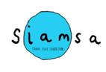

***“Now that your children have covered the laws of Physics, we are introducing them to environmental chemistry”***

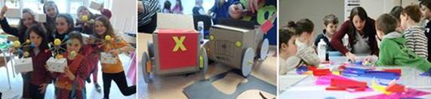

Kilkenny County Council Arts Office is delighted to be hosting its 2014 ‘Siamsa’ programme for 5 to12 year olds. This year a five week programme runs on Sunday’s March 23rd and 30th, May 4th, 11th, and 18th. The programme will offer children the opportunity to learn about the natural environment around them through the integration of science and art using a variety of exciting workshops and projects.

‘Siamsa’ has been part of the Arts Office’s programme since 2011. This fun programme has supported children in developing numerous skills including drawing, painting and making in a diverse range of media. The workshops have included origami, clay modelling, Lego art as well as textile work. Our most recent workshop included arts and science working together.

Following the positive experiences of previous participants, this year’s workshops include practical, hands-on learning experience through scientific experiments and art making projects. Participants will learn about the water cycle and plants by creating their own mini greenhouse garden, explore the secret lives of flowers, get down and dirty with the surprising science of soil, extract DNA from a strawberry and more curious discoveries!

DNA Detectives

As part of the Kilkenny Arts office's 'Siamsa programme', on Sunday, May 4th, these DNA detectives extracted DNA cells from a Strawberry and built a DNA sculpture from recycled art materials!

**[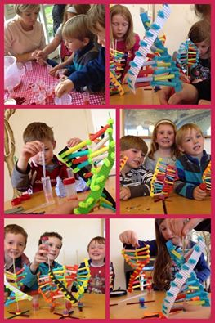](https://www.facebook.com/photo.php?fbid=770036896347836&set=a.204826792868852.51328.165827706768761&type=1)**

Smart lab forensics was a great hit, fingerprinting, latent prints, extracting DNA from strawberries and building their own model to take home. For more information on upcoming events, parties or camps contact michelle or Orla 0879741227/0863768204

**Ends.**

For further information contact:

Mary Butler

E: [mary.butler@kilkennycoco.ie](mailto:mary.butler@kilkennycoco.ie)

W: <http://miniurl.com/c4kI>

Kilkenny County Council Arts Office Partner Local Authority of the ArtLinks Programme [www.artlinks.ie](http://www.artlinks.ie)

**___________________________________________________________________________**

**Kilkenny Events**

**Upstairs Gallery – ‘More is More’**

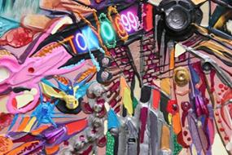

Venue: The Upstairs Gallery, The Watergate Theatre, Parliament Street, Kilkenny City

Date: **Thursday May 1st – May 30th**

Catherine Ryan is a mixed media painter whose main obsession is with city life. Her painting/collages consist of small objects incorporated into intricate playful pieces.

Catherine has just returned from her first international exhibition in New York City.

W: [www.catherineryanart.com](http://www.catherineryanart.com)

[www.thecopperhousegallery.com](http://www.thecopperhousegallery.com)

Email: [redzer3@gmail.com](mailto:redzer3@gmail.com)

Mobile: 0857053979

Watergate: [www.watergatetheatre.com](http://www.watergatetheatre.com)

Upstairs gallery: <http://www.upstairs-gallery.org/>

**___________________________________________________________________________**

**Upcoming Workshops with Tunde Toth in Inistioge, Co. Kilkenny**

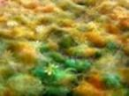

Papermaking day

Date: **25th May**

Time: **10am – 5.30pm**

Fee: **€35** per workshop OR **€65** for the full day – including all materials.

Artist`s Talk: The day`s programme includes a short illustrated presentation on contemporary paper art and related artistic practices.

**10am – 1pm:** Hand Papermaking – beginners and/or some experience  
Introducing traditional and contemporary techniques of making beautiful textured and decorated handmade papers from pure plant fibres and recycled materials.

**2.30 – 5.30pm:** Silk Fibre Papermaking – beginners and/or some experience  
This workshop introduces contemporary techniques used in silk papermaking using a variety of raw silk fibres combined with plant fibres and dyes; creating unique, colourful, striking silk papers ideal for many projects: collage works, decorations, textile art processes and sculptural/installation projects.

Batik - beginners and/or some experience

Date: **15th June**

Time: **10.30am – 5pm**

Fee: **€70** for the full day workshop – including all materials.

This is a full day course on BATIK: introducing a traditional, ancient technique of dyeing and decorating fabrics using hot wax as a resist and fabric dyes. Covering various techniques and processes this workshop offers an overview and an insight into this fascinating art form.

For further information and bookings, please contact Tunde directly on 087 254 3362 or email: [tundetune@gmail.com](mailto:tundetune@gmail.com)

[www.tundetothpaperart.blogspot.com](http://lists.visualartists.ie/lt.php?c=1153&m=4193&nl=1&s=e784eec6bf8bb9680747b324b9c9eee1&lid=87327&l=-http--www.tundetothpaperart.blogspot.com)  
[www.tundetoth.com](http://lists.visualartists.ie/lt.php?c=1153&m=4193&nl=1&s=e784eec6bf8bb9680747b324b9c9eee1&lid=87328&l=-http--www.tundetoth.com)

**___________________________________________________________________________**

**Upcoming Workshops at the Hillside Studio**

Hillside Studio, Donoughmore, Ballyragget, Co. Kilkenny

* Traditional Mosaic Workshops

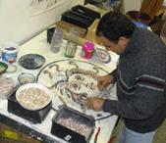

* Cost **€85.00 | 10 am – 5pm**

Working from your own design or ideas and inspiration from the studio you can make a wall mural, mirror, table, sculpture, mosaic a step or stairs and even a fireplace.

* Calligraphy Workshops
* Cost **€70.00 | 10.am – 5 pm**

Emerge yourself in a calligraphy course and discover the world of beautiful cursive script. The art of writing can be at your fingertips introducing you to the many styles including sans serif, roman, chancery cursive, uncial, black letter and olde english.

* Pen and Ink Workshops
* Cost **€80.00 | 10am – 5pm**

This beautiful form of expression using only a simple pen to achieve a range of techniques and styles is what makes pen and ink drawing appeal to artists of all ages, abilities and interests.

* Portraits in Pencil Workshops
* Cost **€80.00 | 10 am – 5pm**

Portraits are often considered the most challenging of all artistic disciplines. This course will take you through the techniques you require to get great results quickly just with an everyday pencil.

* Painting Landscapes in Watercolour and Oil
* Cost **€150.00** for 16 hours tuition.

Looking to develop or improve your landscape skills? This course will give you the basic knowledge and understanding of the subject plus an opportunity to learn more about it. Suitable for all levels.

For more information, dates (all dates to suit students) and bookings, please call Colette on 086 3691443 or email [obriencolette1@hotmail.com](mailto:obriencolette1@hotmail.com)

**___________________________________________________________________________**

**Bealtaine Festival, 1st – 31st May**

**[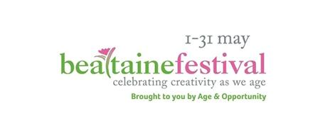](http://bealtaine.com/)**

May belongs to the Bealtaine festival, celebrating creativity as we age! Over 120,000 people now take part in Bealtaine. From dance to cinema, painting to theatre, Bealtaine showcases the talents and creativity of both first-time and professional older artists. There will be many events taking place throughout Kilkenny City and County during the month of May.

For a listing of Kilkenny events, see <http://tinyurl.com/nesy8rt>

**___________________________________________________________________________**

### [Cleere's Trad Music Session](http://kilkennyevents.ie/listings/cleeres-trad-music-session-2014-05-19/)

[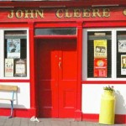](http://kilkennyevents.ie/listings/cleeres-trad-music-session-2014-05-19/)

### The longest running trad night in Kilkenny.

### Date: 19th May, 9.30pm

### Venue: Cleere’s bar & theatre

### Admission: Free

### W: [Click here](http://cleeres.com/trad-music/)

**___________________________________________________________________________**

**Barnstorm theatre company - Youth Drama Camp**

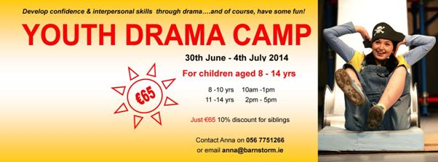

For children aged 8 to 14 years

Develop confidence and interpersonal skills through drama

Facilitated by a professional youth drama facilitator

* The cost is **€65**, with a 10% discount for members of the same family
* Parental consent, a registration form and a non-refundable deposit of €30 is required to secure a place by **13th June 2014**
* Please make cheques payable to: Barnstorm Theatre Company
* If you have any further questions please do not hesitate to contact **Anna** at [anna@barnstorm.ie](http://kk-moss/Sites/arts_office/Shared%20Documents/Julianne%20Morgan/E-bulletin/16th%20May%20e-bulletin/anna@barnstorm.ie)or 056 7751266.

**___________________________________________________________________________**

**Twin Headed Wolf**

[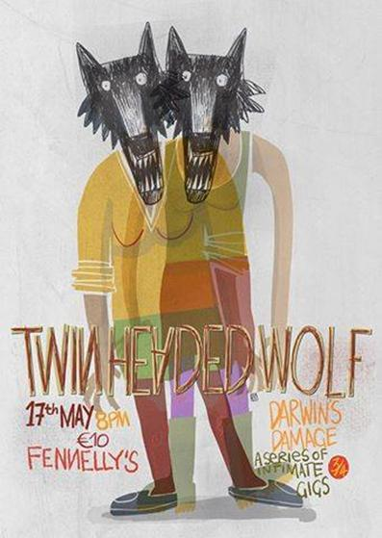](https://www.facebook.com/photo.php?fbid=10152465269179874&set=a.131103179873.128635.593999873&type=1&relevant_count=1)

Date: **17th May, 8pm**

Admission: **€10**

Venue: Fennelly’s, Upper bridge street, Callan, Kilkenny.

Fennelly’s is an independent contemporary space curated by Etaoin Holahan.

This Saturday get yourselves to Fennelly's for this gorgeous gig with Twin Headed Wolf, the third of four Darwin's Damage intimate gigs to raise money for our poor broken barn!

Facebook: [https://www.facebook.com/KilkennyArtsOffice?ref=hl#!/fennellysbridgest](https://www.facebook.com/KilkennyArtsOffice?ref=hl%23!/fennellysbridgest)

**___________________________________________________________________________**

# Kilkenny-born artist Richard Mosse Wins 2014 Deutsche Börse Photography Prize

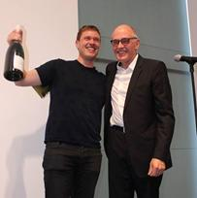

Richard Mosse has won the 2014 Deutsche Börse Photography Prize for his series The Enclave. Mosse’s dream-like, false-color portraits taken in the Democratic Republic of Congo, where 5.4 million people have died of war related causes since 1998, were shot using Kodak Aerochrome, and the series recently represented Ireland at the 2013 Venice Biennale.

Read more at [http://tinyurl.com/l6k8ycu](http://tinyurl.com/l6k8ycu%20)

**___________________________________________________________________________**

[**Concert: Davidson College Presbyterian Church Chancel Choir from North Carolina**](http://kclr96fm.com/events/north-carolina-choir/)

[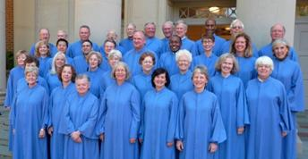](http://media.kclr96fm.com/media/Chancel-Choir.jpg)

Venue: St Canice’s Cathedral, Coach Rd

Date & Time: **Monday, 19th May at** **8pm**

Admission: **Free**

On Monday 19th May at 8pm the chancel choir of Davidson College from North Carolina in the United States of America will give a concert in support of the Music and Restoration Fund at St Canice’s Cathedral Church in Kilkenny.

More info at <http://kclr96fm.com/events/north-carolina-choir/>

**___________________________________________________________________________**

**Library News**



Mosaic Workshop with Maedhbh Brosnan of Smidirini Mosaics.

**[](http://smidirinimosaics.ie/)**

Venue: Ferrybank Library

Date: **Friday, 16th & 23rd May, 2.30pm – 4.30pm**

**Cost: €25 fee for the full course.**

**Telephone:** 051 897200 to book

**Contact Person:** Patricia Nolan

**E mail:** [ferrybank@kilkennylibrary.ie](mailto:ferrybank@kilkennylibrary.ie)

Fuss on the bus (Bealtaine 2014)

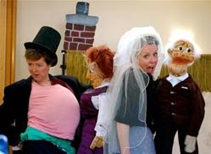

Carnation Theatre, photo by Mike Finn

Mary and her best friend, Bridie have a ritual. Each year they take the 33 bus to Balbriggan. *Fuss On The Bus* will be tailored to each city/ town/ area in which it is performed. The company will gather information about journeys/ bus routes that people would have or continue to take as part of the show.

Venue: Graiguenamanagh Library

**Date: Thursday, 29th May, 11am**

**Telephone:** +353 (056) 4440561

**Contact Person:** Mary Morrissey

For more information contact:Mairead Devlin ph.: 086 836 2820 or Mary O'Driscoll ph.: 087 678 3812 or email [carnationtheatre@gmail.com](http://kk-moss/Sites/arts_office/Shared%20Documents/Julianne%20Morgan/E-bulletin/16th%20May%20e-bulletin/carnationtheatre@gmail.com)

Craft workshops throughout the month of May (Bealtaine 2014

Venue: City library, John’s Quay

Date: **to 31st May**

Email: [citylibrary@kilkennylibrary.ie](mailto:citylibrary@kilkennylibrary.ie)

**___________________________________________________________________________**

**Butler Gallery**

Liam O Callaghan – ‘If and then’

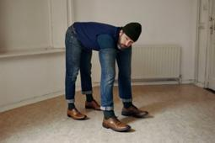

Date (s): **26th April 2014 – June 8th, 2014**

Open Daily, **10am – 5.30pm**

The Butler Gallery is delighted to present if and then… a multi-media exhibition by Dublin based artist Liam O’Callaghan. O’Callaghan is one of Ireland’s most interesting younger artists at work today. His art expresses a willingness to engage with the absurdity of life and encourages us to look anew at ourselves and the world in which we live.

National drawing day

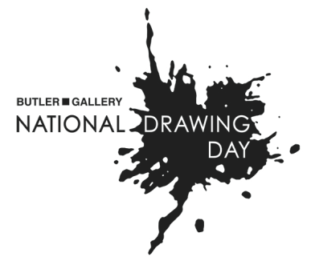

Venue: Butler Gallery Kilkenny Castle and Park

Date & time: **Saturday 17th May, 12-4pm**

Admission: Free, Registration for the event will take place in the Parade Tower, where visitors can pick up information about the day’s activities and a free National Drawing Day t-shirt.

What to expect? The unexpected! Have you ever thought about drawing with wire? Or making your mark alongside drawing machines? Prepare to explore the Castle Park with new eyes - get Stitched Up with local artist Caroline Schofield, visit The Sound Garden and The Butterfly Project, take a walk on the wild side and create some nature-inspired Green Graffiti or create your owndrawing of Kilkenny Castle with architect Mark Costello.

For more information contact Bairbre-Ann at the Butler Gallery on 056 7761106.

<http://www.butlergallery.com/national-drawing-day-2014/>

<https://www.facebook.com/events/616057225156126/>

Read more at <http://www.butlergallery.com/>

**___________________________________________________________________________**

**What’s happening in the Watergate?**

### Maytime Melodies

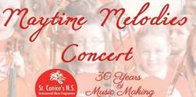

Date(s): **20th May 2014 until 21st May 2014**  
Time: ***7:30 PM - 9:30 PM***

**Tickets:** **€10/€5**

St Canice’s N.S Instrumental Music Programme presents the ever popular Maytime Melodies Concert.

[www.stcanicesmusicprogramme.ie](http://www.stcanicesmusicprogramme.ie)

Find on Facebook | Follow On Twitter | Official Website

### The Unremarkable Death Of Marilyn Monroe

### The Unremarkable Death Of Marilyn Monroe

### Date(s): 22nd May 2014

### Time: *8:00 PM - 10:00 PM*

**Tickets:** **€16/€12**

This is Monroe as we’ve never seen her before: August 5th, 1962 – alone in her bedroom, in dressing gown and slippers; no glitz, no glamour, no masks.

[Find on Facebook](https://www.facebook.com/DyadProductions?fref=ts) | [Follow On Twitter](https://twitter.com/dyadproductions) | [Official Website](http://www.dyadproductions.com/)

### Headway Concert

### Headway Concert

### Date(s): 24th May 2014

### Time: *8:00 PM - 10:00 PM*

### **Tickets:** €20/€17

### A Concert In Aid Of Headway – Brain Injury Services & Support. Featuring Iarla O Lionaird, Mick Hanly, Michael Coady, Castlecomer Male Voice Choir, Glaslinn Female Voice Choir, Conor Brassil, Jen & Elise Ramsbottom, Alan Hayes & Fionn Gardner.

No Crows

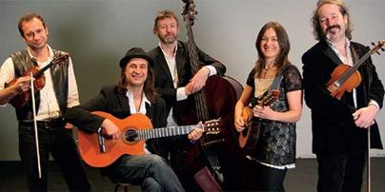

Date: **29th May**

Time: **8:00 PM - 10:00 PM**

Tickets: **€12/€10**

The band has many successes and achievements under their belt, including performances at some of Europe’s top festivals, Glastonbury and Dranouter being notable examples.

View more at <http://watergatetheatre.com/>

Want tickets? Call the box office now on 056-7761674 or click here to book online: [https://www.ctb.ie/tickets/watergate/?shows=%](https://www.ctb.ie/tickets/watergate/?shows=%25)

**___________________________________________________________________________**

**National craft gallery**

Beauty is the First Test



**16th May 2014 – 9th July 2014**

Mathematical concepts underpin many craft techniques, especially around textile construction, and can be key tools for artistic development. This exhibition’s intention is to unlock and demystify maths by showing unique and stimulating works of art.

For more info of the above, please visit: <http://www.nationalcraftgallery.ie/exhibitions>

[Beauty is the First Test: Curator Tour with Liz Cooper](http://www.nationalcraftgallery.ie/exhibitions/beauty)

Date: **Fri 16th May, 6pm**

Admission: **Free**

Curator of [Beauty is the First Test](http://www.nationalcraftgallery.ie/exhibitions/beauty) Liz Cooper will give us a short tour of the exhibition and discuss the works involved. This will be followed by a launch of the exhibition at **7pm** by Tomás Ó Ruairc, Director of the Teaching Council.

National drawing day – The Big Draw

Date: **Saturday 17th May, 12pm to 4pm**

Venue: National craft gallery, Castle Yard

Admission: **FREE**, drop-in events, no booking required!

National Craft Gallery welcomes drawers of all ages and abilities for National Drawing Day 2014. Find inspiration from our current exhibition Beauty is the First Test and then follow the drawing trail over to the Castle and Butler Gallery for more creative drawing workshops!

Crafternoon tea

Date: **Friday, 23rd May at 2pm**

Admission: **Free and open to all**

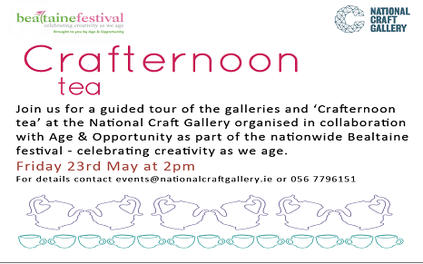

[LATE DATE: Spirostitch Textile Workshop](http://nationalcraftgallery.cmail3.com/t/y-l-iludjuk-jlklezkr-ti/)

Date: **29th May, 6.30pm**

**Admission: Free event. No booking required.**

We'll be getting crafty for our Late Date this month, trying our hand at stitching patterns and embroidery inspired by the pattern and geometry of the spirograph in our current exhibition [**Beauty is the First Test**](http://nationalcraftgallery.cmail3.com/t/y-l-iludjuk-jlklezkr-td/).

Read more about the above events at <http://www.nationalcraftgallery.ie/events>

For more information: [events@nationalcraftgallery.ie](mailto:events@nationalcraftgallery.ie) / 056 7796151

**___________________________________________________________________________**

**Music in Kilkenny**

College Symphony Orchestra on Saturday night

Venue: Castalia Hall

Date & time: **17th May at 8 pm**

Tickets: **€5 on sale at the door**

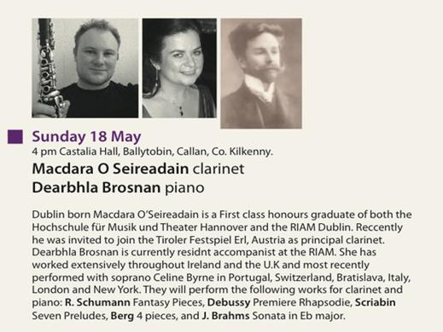

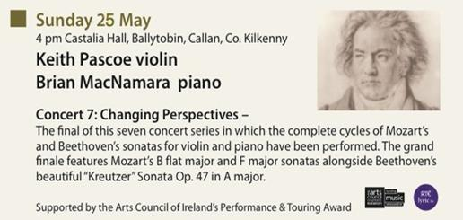

Tickets as usual will be available at the door from 3.30 onwards.

Tickets for above concerts: **€15.00** **(€10** concession)   
Season ticket: **€100.00**   
Further information:  
Susan Proud – 0861777017  
email: [mikilkenny@gmail.com](mailto:mikilkenny@gmail.com)

View more concerts at <http://www.musicinkilkenny.com/whats-on.html>

**___________________________________________________________________________**

**Introduction to Tapestry Weaving – 2 Day Workshop**

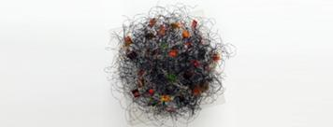

Venue: Textile Works Studio,

              Annamult,

             Bennettsbridge,

             Co. Kilkenny

Date: **14th & 15th June 2014**

Fee: **€150,** inclusive of all materials and a light lunch and refreshments on both days.

This course is for complete beginners and those who already have skills in tapestry weaving and are keen to explore the medium further.

If you are interested in attending the Workshop please email Anne at [anneharte.annamult@gmail.com](mailto:anneharte.annamult@gmail.com) for a reservation form and further details of the Course. Places are strictly limited to 10 participants so early booking is recommended

Phone: 087 297 8033

E‐mail: [anneharte.annamult@gmail.com](http://kk-moss/Sites/arts_office/Shared%20Documents/Julianne%20Morgan/E-bulletin/16th%20May%20e-bulletin/anneharte.annamult@gmail.com)

**___________________________________________________________________________**

**Set theatre – We Cut Corners, Free gig**

[Concert: We Cut Corners [support: Lisa Flume]](http://www.set.ie/events-guide/events/we-cut-corners)

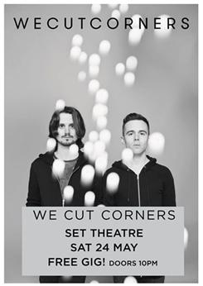

Venue: Set Theatre, Kilkenny

Date: **Saturday, 24th May,** **10pm**

Free admission

More info at <http://www.set.ie/>

**___________________________________________________________________________**

**Kats Theatre Group – ‘SPOILER ALERT’**



KATS return to their spiritual home of John Cleeres', for three nights of theatre with a difference. 'Spoiler Alert' will aim to bring some of the best loved and most Iconic movies scenes to the stage.

Spoiler Alert will **run from May 14th - 17th** in Cleere’s Theatre. Bookings can be made by calling Cleere’s on 056-776 2573, and are priced at just **€10** with some cinema treats included. [See more](https://www.facebook.com/katstheatregroup?fref=photo)

**___________________________________________________________________________**

**CATS THE MUSICAL**

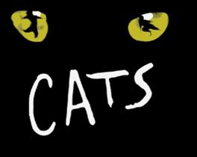

JPR PRODUCTIONS / STARLIGHT present their 10th Anniversary production CATS THE MUSICAL with a youthful cast made up of over 70 talented county Kilkenny children all under 15 years of age !! CATS is one of Andrew Lloyd Webbers most famous and successful shows and it broke records as the longest running musical of all time when it celebrated 21 years in London's West End - the show has been translated into many languages and performed all across the world and now for the first in county Kilkenny.

The show will run at Callan Parish Hall for 3 performances only **Thursday 19th to Saturday 21st of June 2014** and tickets cost **€10 all seats.** Booking can be made in advance by calling the ticket hotline 083 118 7801 or emailing [jasonpaulryanproductions@gmail.com](mailto:jasonpaulryanproductions@gmail.com)

Facebook – JPR productions: [https://www.facebook.com/#!/JPRProductionsIreland?fref=ts](https://www.facebook.com/%23!/JPRProductionsIreland?fref=ts)

**___________________________________________________________________________**

**Hole in the Wall – Singspiel**

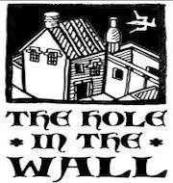

LES DEUX MAGGOTS: A tenor in other words (LDM)

Date: **June 15th (Sun)**

Venue: Archer Room of Hole in the Wall

Admission: **€15 on door** or from Hole in the Wall on weekends

This SingSpiel is the story of James Joyce - with particular focus on his sojourn in Paris (1920/30s). It will contain readings of excerpts from ‘Ulysses’ and ‘Portrait of an Artist as a Young Man’, his play ‘Exiles’, various biographies and also focus on his talent as a - Count John McCormack quality - tenor.

Paris En Reve (PER)

Date: **July 13th (Bastille Day) (Sun)**

Venue: Archer Room of Hole in the Wall

Admission: **€15 on door** or from Hole in the Wall on weekends

This is a montage about the city of Paris and its nightlife with songs from ChAznavour (the story of Charles Aznavour (‘Emmenez Moi’, ‘La Boheme’, ‘Etre’, and Jacques Brel’s ‘Dans Le Port d’Amsterdam’ sung by Michael Conway) and footage from Hole in the Wall’s show - Being Edith Piaf).

Ballad Session every Friday and most Saturdays **from 10.00pm**.

Call: 087 8075650

Facebook: [http://tinyurl.com/kkhvwse](http://tinyurl.com/kkhvwse%20)

W: <http://www.holeinthewall.ie/>

**___________________________________________________________________________**

**YIFM Film Summer camps**

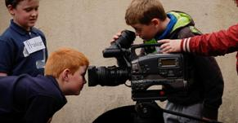

How about a summer camp with a difference this year? Have you ever dreamed of working on a film set, of making your very own movie, of shouting those famous words ‘lights, camera, action!’. Well, now is your chance.

### Dates for the summer camps are:

**June 30th – July 4th**  
**July 21st – July 25th**   
**July 28th – August 1st**

**Price: €140**

Book online at <http://yifm.com/summer-camps-2014/>

**___________________________________________________________________________**

**Upcoming Classes at Blackstack Studio**



Blackstack Studio, 42 Parliament St., Kilkenny

SATURDAY WORKSHOPS

* Bookbinding II – Continuation (**Saturday 24th May. 10am-4pm,** €80)
* Printmaking for Teachers (**Saturday 10th May & Saturday 17th May,** €160)

Bookings can be made on the website [www.blackstackstudio.com](http://www.blackstackstudio.com) or by emailing [sylvia@blackstackstudio.com](http://kk-moss/Sites/arts_office/Shared%20Documents/Julianne%20Morgan/E-bulletin/21st%20March/sylvia@blackstackstudio.com) . If you have a group of 3 or 4 people we can also arrange a special workshop to suit you - email Sylvia at the above address.

More info about the above workshops at <http://miniurl.com/7vXo>

**___________________________________________________________________________**

**Art Group – Bennettsbridge**

[](http://www.ckart.co.uk/index.htm)

Art classes each Saturday morning in the newly refurbished community centre. Classes are from **12-2pm**.

**___________________________________________________________________________**

**Kilkenny’s County Fleadh in Mullinavat**

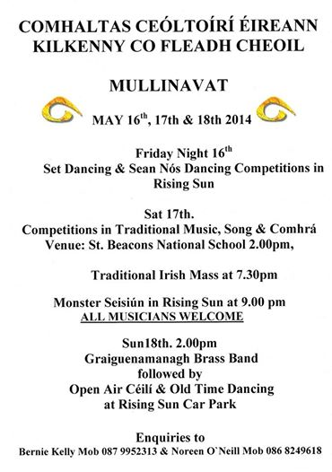

Kilkenny Fleadh taking place this week-end in Mullinavat beginning on Friday night with Set-Dancing and sean-nos dancing competitions at The Rising Sun. Competitions in music, song and comhra on Saturday , session on Saturday night in The Rising Sun. Open Air Ceili on Sunday afternoon.

**___________________________________________________________________________**

**Kilkenny School of Music – Discovery Day**



Date: **Sunday afternoon, 25th May**

Free mini-lessons on Violin, Cello, Recorder & Piano for boys & girls in Junior & Senior Infants.

Booking essential, contact Anne at 056 77 62969, between 3pm & 6pm, Tuesday to Friday.

W: <http://www.kilkennyschoolofmusic.net/>

**___________________________________________________________________________**

**Rebecca Storm – Stoneyford Community Centre**

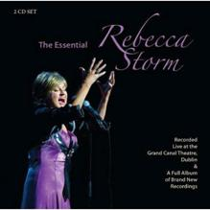

Rebecca Storm will perform at Stoneyford Community Centre on **Saturday 28th June 2014** from **8pm**, tickets available from Fred on 087-9715304 and from Walsh’s Shop Stoneyford & O’Gradys Pub.

**___________________________________________________________________________**

**Grennan Mill Craft School – Short courses Jewellery & Metalcraft**

**[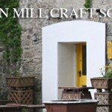](http://www.thomastownparish.ie/wp-content/uploads/2013/04/Grennan-Mill-Craft-School.jpg)**

* Enamelling & Silver Jewellery for Beginners & Improvers

**Thurs 26th - Sat 28th June / 10am-5pm**

3 day course exploring many techniques in Silver Jewellery making & kiln enamelling.

Minimum 6 – Maximum 9 persons

Course Fee: **€160**

Materials Fee: **€25** - includes 10grms silver, enamels, copper, solders & sundries.

* Silver Jewellery Making for Beginners & Improvers

**July 12th (Sat) & 13th (Sun) 10am-5pm**

Make your own designs or replicate a chosen piece of jewellery using precious metals, stones & other chosen materials. Learn many aspects of working with silver including soldering, cutting, filing, stone-setting & more.  
Course Fee: **€140**

Materials Fee**: €25** (10grms silver, enamels, copper, solders & sundries)

Metalcraft for Beginners & Improvers

**June 30th(Mon) - July 3rd(Thurs) 10am-4pm**

Explore many techniques in metalsmithing & jewellery-making, including enamelling, soldering, forming, repousse work, surface decoration & more

Course Fee: **€170**

Materials Fee: **€15** (copper & gilding metal, enamels, solders & sundries)

**For all summer courses:**

* Application Forms available from Grennan Mill Craft School, Mill Street, Thomastown, Co. Kilkenny
* **Completed application form and non-refundable deposit of €50 are required by:**  
  **Friday 30th May for ALL courses**
* Cheques made payable to ‘Grennan Mill Craft School.’
* For more info on course content, please contact Eva at [evylynch@hotmail.com](mailto:evylynch@hotmail.com)  
  To book a place please contact Alex at [grennanmill@eircom.net](mailto:grennanmill@eircom.net)
* Should Grennan Mill cancel the course, your monies will be refunded in full.

**For further details: Tel: (056) 7724557** [grennanmill@eircom.net](mailto:grennanmill@eircom.net)

**___________________________________________________________________________**

**Castlecomer Discovery Park – The Art of Meditation & Meditative Art**

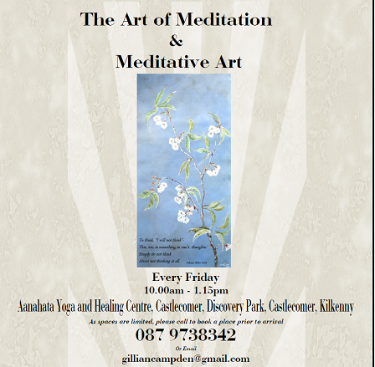

**Every Friday 10.00am - 1.15pm**

**Venue:** Castlecomer Discovery Park, Castlecomer, Kilkenny

**10.00 am-11.00 am** Guided Meditation Session

Suitable for all levels, including beginners. The session will focus on developing mindfulness and learning to live in the present moment.

**11.15 am- 1.15 pm** Meditative Painting

After a short break this session will help you to develop your own creativity and style.

087 9738342 or email [gilliancampden@gmail.com](http://kk-moss/Sites/arts_office/Shared%20Documents/Julianne%20Morgan/E-bulletin/16th%20May%20e-bulletin/gilliancampden@gmail.com)

Aanahata Yoga and Healing Centre,

Castlecomer Discovery Park,

Castlecomer, Kilkenny

As spaces are limited, please call to book a place prior to arrival

Cost: If you are attending the painting class it is recommended that you attend both sessions if you can at **€12.00**

*Or if you would like to attend only one session the following charges apply*

**Meditation Session:** Honouring the tradition of Dana (generosity) meditation is on a donation basis.

**Meditative Painting: €12.00**

W: <http://aanahatayoga.ie/>

**___________________________________________________________________________**

**The Abhainn RíFestival**

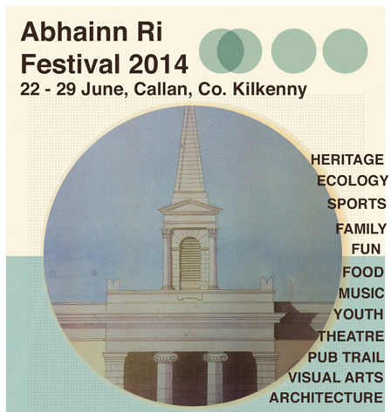

More info at <http://abhainnrifestival.com/>

**___________________________________________________________________________**

**Courses / Training / Jobs**

**___________________________________________________________________________**

**Employment Vacancy – Animator on Puffin Rock**

[](http://www.cartoonsaloon.ie/wp-content/uploads/2009/04/CS_Logo_black-text.png)

Project: Puffin Rock 39×7-minute episodes.  
Position: Animator.  
Start date: as soon as possible.  
End date: end of 2014/beginning 2015.  
Location: Kilkenny (this is non-negotiable unfortunately)

Please send your application, including links to your online portfolio, to [jobs@cartoonsaloon.ie](http://kk-moss/Sites/arts_office/Shared%20Documents/Julianne%20Morgan/E-bulletin/16th%20May%20e-bulletin/jobs@cartoonsaloon.ie)

W: <http://www.cartoonsaloon.ie/jobs/>

**___________________________________________________________________________**

**PRODUCER PROJECT ARTS CENTRE**

# [Theatre Forum Ireland Homepage](http://www.theatreforum.ie/)

# Project Arts Centre is delighted to announce a call for applications for the new and exciting role of Producer. The Producer oversees and manages Project CATALYST and works alongside the Artistic Director and Curator of Visual Arts in developing Project’s programme.

The closing date for receipt of all applications is **16th May 2014.**

Applications will be accepted by email only and should be submitted to [annette@projectartscentre.ie](http://kk-moss/Sites/arts_office/Shared%20Documents/Julianne%20Morgan/E-bulletin/16th%20May%20e-bulletin/annette@projectartscentre.ie)

Read more at [http://tinyurl.com/pgagr6u](http://tinyurl.com/pgagr6u%20)

|  |  |
| --- | --- |
| |  | | --- | |  | |

**___________________________________________________________________________**

# The Board of Fire Station Artists’ Studios Recruiting for the position of Director



The position of Director of FSAS will require strategic, operational, financial and programming management. Full details are available on the website: [www.firestation.ie/news](http://www.firestation.ie/news) or email [artadmin@firestation.ie](http://kk-moss/Sites/arts_office/Shared%20Documents/Julianne%20Morgan/E-bulletin/16th%20May%20e-bulletin/artadmin@firestation.ie) to receive the job description and for information on how to apply.

Fire Station Artists’ Studios is supported by the Arts Council and Dublin City Council. Fire Station is an equal opportunities employer.

**Deadline for applications: Monday, 26th May, 2pm.**

Read more at [http://tinyurl.com/l2rozt9](http://tinyurl.com/l2rozt9%20)

**___________________________________________________________________________**

**Foundation & Short Courses Director (part-time) at The Lir**

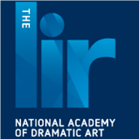

The Lir, National Academy of Dramatic Art at Trinity College, is seeking to appoint a dynamic and experienced teacher/theatre practitioner to lead on all aspects of its new Foundation Diploma in Acting and Theatre.

Interested candidates should submit a letter of application and a full CV to

anne.fitzpatrick@thelir.ie by **5pm on June 2nd 2014.**

* [Foundation__Sho...](http://www.theatreforum.ie/uploads/tx_frjobs/Foundation__Short_Courses_Director_Job_description.pdf)

**___________________________________________________________________________**

# Journalist

# IPN Communications Ltd.

## Description

IPN Communications are looking to hire a Journalist. – Applicants from Dublin Belfast Manchester and London are welcomed.

IPN Communications Ltd, we specialise in Community and Hospital Magazines in Ireland and UK. We seek to recruit full and part-time freelance Journalists to join our editorial team.

It is important that you have a passion for current affairs, business, health and pharmaceuticals within ROI and England.

Interested applicants should apply at [**Apply Now**](http://www.irishjobs.ie/apply/7300316)

W: <http://www.irishjobs.ie/Jobs/Journalist-7300316.aspx>

**___________________________________________________________________________**

**Graphic Designer**



 Graphic Designer required for a maternity leave contract

**Purpose of Position:** Full responsibility for all NCI graphic design, branding and visual communications. The role includes the design of all elements of the NCI brand and sub-brands which includes designing and producing brochures, adverts, invitations, posters, flyers, banners and digital materials.

**This role will close at 12pm on Monday 26th May 2014.**

[**Apply Now**](http://www.irishjobs.ie/apply/7310235)

W: <http://www.irishjobs.ie/Jobs/Graphic-Designer-7310235.aspx>

**___________________________________________________________________________**

**PULSE Call Out for Professional Actors in Limerick**

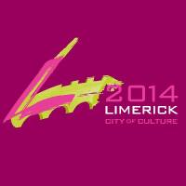

PULSE (Limerick City of Culture's Theatre Legacy Project Part One) are looking for Professional Actors from or living in Limerick to take part in a week long workshop. This is just one aspect of the programme for PULSE taking place from 20th - 29th of June 2014.

Dates: Monday **23rd June- Saturday 28th June**. (10am-5pm) Full Time Course  
  
Please send your up to date CV and headshot to: [theatrelegacyproject@gmail.com](mailto:theatrelegacyproject@gmail.com)

**DEADLINE to apply: JUNE 1ST 2014 AT 5PM**  
  
If you have any queries please email Marie at [theatrelegacyproject@gmail.com](http://kk-moss/Sites/arts_office/Shared%20Documents/Julianne%20Morgan/E-bulletin/16th%20May%20e-bulletin/theatrelegacyproject@gmail.com)

W: https://www.facebook.com/LimerickCityofCulture

**___________________________________________________________________________**

**Photographic Lab Assistant – Internship**



The intern will gain practical experience in photo development, canvas printing, photographic gifts, digital printing, and photographic restoration.

Please send you CV for the attention of Linda Campbell [lindagorey@mccabespharmacy.com](http://kk-moss/Sites/arts_office/Shared%20Documents/Julianne%20Morgan/E-bulletin/16th%20May%20e-bulletin/lindagorey@mccabespharmacy.com)

Employer

Wembar Ltd  
Mc Cauleys Pharmacy  
69 Main Street  
Gorey   
Co Wexford

More info at <http://tinyurl.com/pb466xe>

**___________________________________________________________________________**

**MA in Screenwriting for Film and Television**

[](http://www.iadt.ie/en/)

This MA gives writers the opportunity to explore, experiment and learn the craft of screenwriting, in conjunction with the development and writing of a full-length screenplay.

1st round of applications: **9th May 2014** .

2nd round of applications (if places available): **27th August 2014**.

More info and application details at <http://tinyurl.com/khy7glg>  **___________________________________________________________________________**

**MA Festive Arts programme**

**[](http://www.irishworldacademy.ie/)**

Applications are now being accepted for the MA Festive Arts programme at the Irish World Academy of Music and Dance, University of Limerick.

The MA Festive Arts Programme at the Irish World Academy of Music and Dance offers students the opportunity to develop skills in arts management, curating, production, performance and research with an emphasis on festivity and the role of festival in society. Bringing together artists, performers, curators, producers and researchers, the MA Festive Arts Programme provides a unique context for the acquisition and development of skills in this field.

For more information on this programme, please visit <http://tinyurl.com/qfr8hlg> or contact [niamh.nicghabhann@ul.ie](mailto:niamh.nicghabhann@ul.ie)

**___________________________________________________________________________**

# CIT Crawford College of Art and Design: Creativity & Change Course

# [https://encrypted-tbn0.gstatic.com/images?q=tbn:ANd9GcSF6_avHdxBl5qX-5HCxa7_5NX5ZFS0wMhNNFa5itBA67lfZlKMsk_5gg0](https://www.google.ie/url?q=http://www.creativityandchange.info/&sa=U&ei=Ye1oU7-hKKq47Abh_ICQBg&ved=0CCwQ9QEwAA&usg=AFQjCNGRMy6gGUOPOwF_nx9oAbCjJnWQTA)

This is a CIT approved Special Purpose Award at Level 8 (10 credits) certificate supported by Irish Aid. The course has several main strands of learning within the context of global citizenship & global and local justice themes.

**DURATION:** Seven 2/3 day blocks **Oct 2014 to May 2015**

**APPLY:** Applications accepted by email. Go website, <http://www.creativityandchange.info> and go to ‘get involved’ page to download application form.

**FEE:** The course fee is subsidized through Irish Aid funding so it can be offered at reduced rate of **€680**

Enquiries to [creativityandchangecit@gmail.com](mailto:creativityandchangecit@gmail.com)

W: <http://www.creativityandchange.info/>

**___________________________________________________________________________**

**Get Together 2014 – Friday, May 23rd 2014 in IMMA**



A national day of coming together with talks, clinics, presentations, information sharing, and a chance to catch up with fellow artists.

Book now at <http://visualartists.ie/visual-artists-ireland/130750-2/>

# ___________________________________________________________________________

[**Carlow Arts Festival – Èigse 2014**](http://www.visualcarlow.ie/events/info/catalan-platter-basket-workshop-with-joe-hogan)

# [Catalan Platter Basket Workshop with Joe Hogan](http://www.visualcarlow.ie/events/info/catalan-platter-basket-workshop-with-joe-hogan)

# [Catalan Platter Basket Workshop with Joe Hogan](http://www.visualcarlow.ie/events/info/catalan-platter-basket-workshop-with-joe-hogan)

Date: **14th June, 11am – 4pm**

Venue: Studio Gallery ‘Make Space’, VISUAL Centre

Cost: **€45** – max 8 people, advance booking only.

In this course, each participant will make a round Catalan platter, a technique which provides a relatively easy route into making a basket.

# Lacing Past & Present with Tara Ní Nualláin

# Lacing Past & Present with Tara Ní Nualláin.

Date: **Sunday 15th June (2pm-3.30pm)**

Venue: Studio Gallery ‘Make Space’, VISUAL Centre

Cost: **€10** – max 15 people, advance booking only.

Each participant will produce a panel of stitched Perspex exploring the potential of combining traditional stitch with modern materials referencing Tara’s Heirloom project.

# Superhero Summer Theatre Camp

# Date: 7th – 12th July

# Venue: Visual Centre

# Cost: €75

Suitable for ages 6+ with or without any previous experience.

A fun-filled week of theatre-based games and creative activities bringing out the superhero in everyone!

View more at <http://www.visualcarlow.ie/events/category/workshops-classes>

# ___________________________________________________________________________

|  |
| --- |
| **Dublin Writers’ Festival**  **Mindshift - Professional Development for Published Authors in partnership with the Dublin Writers' Festival** |

|  |
| --- |
| http://ih.constantcontact.com/fs124/1102241209221/img/196.jpg  **THE BUSINESS OF BEING A WRITER**  **Date & time: 10am - 4pm, 17th May**  **Cost: €60/€50 IWC members**    What type of funding and supports are there for writers? Who is eligible for artist tax exemption?  How can writers set themselves up as a business? What are the ways to generate alternative sources of income? Mia Gallagher and others reveal and unpack the mysteries of funding and finances in literature. A must for the enterprising writer.    **Booking:  01 872 1302 or** [on our site](http://r20.rs6.net/tn.jsp?f=001MnTl3_QjuyL5B-aRjlhINk4tWqnUmBUE1hKqsPl_co2Wy2Tq0j9fT3_jQsXip0D53iUKMN37i88IGj55OOe-u7QcGyPkEop9WoYIXpu7WjKGdvwZS_-IFW3epCeM5Revg6t_kmhtPYZIR2-bkpntvfizBzaK-97gTrKlLLZEB0E=&c=Br_jK3bZcwm-kLzEj66RW03Y6BZS-3ersWg_2udNhghcbW3FLqZMCA==&ch=vIpKN6eDQRX6_DUxb6g5Gci6lzfpxX_qfvqRLoMOB4xjPpSt4OFb_A==)**.** |

|  |  |
| --- | --- |
| |  | | --- | | http://img.constantcontact.com/letters/images/1101116784221/S.gif | |

|  |
| --- |
| **Writing Historical Fiction with Jo Baker, as part of the Dublin Writers' Festival** |

|  |  |  |  |  |
| --- | --- | --- | --- | --- |
| http://www.dublinwritersfestival.com/wp-content/uploads/2014/04/Jo-Baker.jpg  **Date & time: 18th May, 12 noon**  **Cost:  €5 booking fee. Click** [**here**](http://r20.rs6.net/tn.jsp?f=001MnTl3_QjuyL5B-aRjlhINk4tWqnUmBUE1hKqsPl_co2Wy2Tq0j9fTxJFY5i3tL0KynABi18LFTxrQe6XmVn0NSGdSooESpBNFNF0Rbk70LQl_w9jDCeVpZhX5sYKg7InVMU5tQvk5wK_5g5DD_ry9GpcSSEl_IWO9npJYUHVIHU=&c=Br_jK3bZcwm-kLzEj66RW03Y6BZS-3ersWg_2udNhghcbW3FLqZMCA==&ch=vIpKN6eDQRX6_DUxb6g5Gci6lzfpxX_qfvqRLoMOB4xjPpSt4OFb_A==) **to book your place.**    How do you go about researching the novel, and how do you know when to stop? In this informal discussion, Jo Baker shares her experiences of writing and researching Longbourn, her acclaimed retelling of Pride and Prejudice from the servants' point of view.   |  | | --- | | **How to Write a Book as part of the Dublin Writers' Festival** |  |  | | --- | | **Date & time: Sun 18 May, 4.00 pm**  **Cost: Admission Free**    Have you ever wanted to write a novel? How do you get it out and on the page? How do you handle structure, dialogue and plot? On Sunday at the Irish Writers' Centre, Sinéad Gleeson will chair a discussion with novelist Liz Nugent, whose debut novel Unravelling Oliver has been at the top of the Irish charts for some weeks; and poet, playwright and novelist Dermot Bolger.    **To book a place go to**<http://bit.ly/1ggAcFT> |   **___________________________________________________________________________**   |  | | --- | | **Publishing Ireland Seminar Series** |  |  | | --- | | http://ih.constantcontact.com/fs124/1102241209221/img/155.jpg  Publishing Ireland is delighted to announce the line-up for our Spring/Summer Seminar Series. Join us for our interactive, applied and practical sessions designed for publishers and industry professionals to get the most out of their business.    **The Book Package: Designing Jackets and How to Write the Perfect Blurb**  **When:**  **Thursday, 22nd May**  **Where:**  Publishing Ireland Offices, 25 Denzille Lane, Dublin 2  **How Much:**  **€200/ €175 (PI Associate Member)/ €150 (PI Member)**  Further details [here](http://r20.rs6.net/tn.jsp?f=001MnTl3_QjuyL5B-aRjlhINk4tWqnUmBUE1hKqsPl_co2Wy2Tq0j9fTxJFY5i3tL0KV_xkmwJS9UtwAnwXss_RMuPbQmM_0sdhy4BY9j-bn_MWht4ZBIEN_bCPmxjs14UmClDa_WSUJpqrcN__XUqttXu31mELL-KNYN2L2LojFS2qzUIkqt4Bo3T6ElRxfv28OyM6yBOxdkRR23gFl_pfewcAeM3CojVbpVMRLjtU4lj1m8y_KjNfCPy3UcMENbsP4xiKSmVeizKUAKHqyijw26JTXrxN2EhT&c=Br_jK3bZcwm-kLzEj66RW03Y6BZS-3ersWg_2udNhghcbW3FLqZMCA==&ch=vIpKN6eDQRX6_DUxb6g5Gci6lzfpxX_qfvqRLoMOB4xjPpSt4OFb_A==)  **__________________________________________________________________________** | |

# Join the Limerick National City of Culture Volunteer Team!

**[](http://www.limerickcityofculture.ie/)**

Limerick National City of Culture has begun taking applications for volunteers who wish to get involved in this year's exciting programme of events. This year Limerick will be the national stage for a host of acts, arts and events from the best in local talent to internationally renowned artists performing in Ireland for the first time.

Deadline: **23/06/14**

Please contact Kate McDonagh, Volunteer Programme Manager 087 9127956 or email  [volunteer@limerickcityofculture.ie](mailto:volunteer@limerickcityofculture.ie)

For more info see <http://tinyurl.com/osxkmqa> or <http://www.limerickcityofculture.ie/>

**___________________________________________________________________________**

**Volunteer at Carlow Arts Festival**

[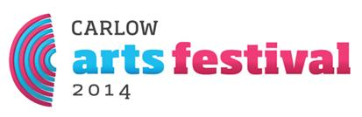](http://carlowartsfestival.com/)

Carlow Arts Festival Volunteer

Get involved in the Carlow Arts Festival **6th - 15th June 2014**. Volunteers needed for Literary Day in Borris House **14/15th June**, also History Day in Huntington Castle **7/8th June**.

Borris House Festival of Writing & Ideas Volunteer

Assist with the Literary strand of the Carlow Arts Festival during the weekend of 14th & 15th June 2014.

Apply at [http://tinyurl.com/nyneh4g](http://tinyurl.com/nyneh4g%20)

Publicity Assistants - Poster etc. Distribution

Distributing flyers/programmes/posters around Carlow Town and County. Putting up posters in various places (with permission from property owner).

Apply at [http://tinyurl.com/keoqfgf](http://tinyurl.com/keoqfgf%20)

Painting/DIY Volunteers

Help with painting shop front and pop up units. Preparing the exhibition and stage venues for Carlow Arts Festival.

Apply at [http://tinyurl.com/lplak5s](http://tinyurl.com/lplak5s%20)

**___________________________________________________________________________**

# Volunteers Required for Family Day Festival

# [Family Day Festival](http://www.familyday.ie/)

One Family is a leading national organisation for one-parent families in Ireland. Our message of ‘Celebrate Your Family – Celebrate All Families’ is embraced in a fun, welcoming atmosphere at our annual Family Day Festival. This free day of festivities is family friendly and all-inclusive. A range of activities from art workshops to magicians, ethnic dance to traditional sports, choirs, to spoken word are offered with something for all members of the family.

We are seeking volunteers to work with One Family staff to help with meeting and greeting, stage management, the sports and activity areas, event set up and tidy up, information booth, and face painting.

Please email Linda Sankey on [lsankey@onefamily.ie](mailto:lsankey@onefamily.ie) or call One Family on 01 662 9212.

**___________________________________________________________________________**

## MUSIC GENERATION LOUTH SUMMER PROGRAMME 2014 ****- NOW BOOKING.****

**TRADITIONAL MUSIC SCHOOL**

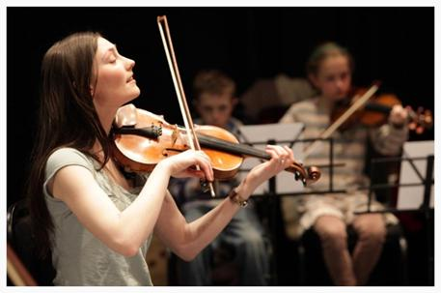

|  |  |
| --- | --- |
| |  | | --- | |  | |

Cost: **€45**

Date: **Mon 30th June – Wed 2nd July (10am-2pm)**

Venue: St Oliver’s Community College, Drogheda

A **traditional music** school focusing on fiddle, tin whistle and guitar. Caters for a range of levels up to advanced. Minimum experience required - one year attending lessons. Other instruments available on request and subject to demand.

More info at [http://tinyurl.com/klyfrlp](http://tinyurl.com/klyfrlp%20)

Email: [musicgeneration@lmetb.ie](mailto:musicgeneration@lmetb.ie)

W: <http://www.musicgenerationlouth.ie/>

**___________________________________________________________________________**

# NYCI Youth Arts Summer School 11th – 13th June - Early Bird Deadline Approaches and Bursaries Announced

# [Youth Arts Programme logo](http://www.youtharts.ie/)

Delivered by NYCI’s Youth Arts Programme, Summer School is a 3-day residential youth arts practice summer school in NUI Galway, running from 11th-13th June 2014.

**REMINDER: EARLY BIRD DISCOUNT ENDING SOON**

NYCI Youth Arts Summer School early bird rate **expires on Friday, 16th May 2016.** This week is your last opportunity to avail of a €50.00 discount on participation. After 16th May, non-members rate will be €300.00 and members rate will be €250.00.

**BURSARIES ANNOUNCED!**

NYCI is delighted to announce that Cork County, Waterford County and Kilkenny Arts Services are offering bursaries to participate in summer school for those living/working in the relevant administrative areas who fulfil criteria. Further details on [www.youtharts.ie/bursaries14](http://youth.us1.list-manage.com/track/click?u=34a7524d115d856708ac53cbd&id=98b428e53f&e=576a67049e)

Further information can be found at [www.youtharts.ie/yass2014](http://youth.us1.list-manage.com/track/click?u=34a7524d115d856708ac53cbd&id=5bd282bcd4&e=576a67049e)

Feel free to contact Anne O Gorman, Senior Project Officer Youth Arts with any questions

01 4255932 or [anneog@nyci.ie](mailto:anneog@nyci.ie)

**___________________________________________________________________________**

# Intergenerational Music Workshops

[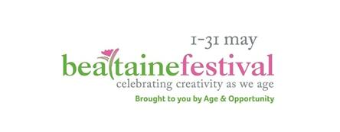](http://bealtaine.com/)

**Age & Opportunity** is delighted to collaborate with **Music Generation (Sligo, Mayo and Donegal)** and **Music Network** to present ***The Iona Connection***Intergenerational Workshops.

These workshops invite young (8 to 18 years) and older (adult) musicians to book in pairs for a ‘musical sharing’ between the generations and between amateur & professional musicians, as part of the Bealtaine festival programmes in Sligo, Mayo and Donegal.

For more details on these free workshops visit [MusicGeneration.ie](http://www.musicgeneration.ie) (finding Mayo or Sligo under ‘Music Education Partnerships) or, for Donegal, email [musiceducation@donegaletb.ie](http://kk-moss/Sites/arts_office/Shared%20Documents/Julianne%20Morgan/E-bulletin/16th%20May%20e-bulletin/musiceducation@donegaletb.ie)

**___________________________________________________________________________**

[**National College of Art and Design**](http://visualartists.ie/jobs-ops/courses/national-college-art-design-cead-summer-programme-2014/) **-** [**CEAD Summer Programme 2014**](http://visualartists.ie/jobs-ops/courses/national-college-art-design-cead-summer-programme-2014/)

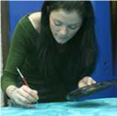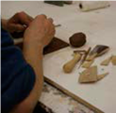

Dates & time: **30th June – 18th July 2014, 10-4pm**

The National College of Art and Design provides an extensive range of part-time art and design courses for beginners and improvers.

For more information, please contact: Seliena Coyle by emailing [cead@staff.ncad.ie](http://kk-moss/Sites/arts_office/Shared%20Documents/Julianne%20Morgan/E-bulletin/16th%20May%20e-bulletin/cead@staff.ncad.ie) or phoning 01 636 4214

More info at <http://46.22.133.24/files/cead_files/Summer_2014_CEAD_web_update.pdf>

[Photography and Digital Imaging Certificate at NCAD | Call for Applications](http://visualartists.ie/jobs-ops/courses/photography-digital-imaging-certificate-ncad-call-applications/)



This one year part-time course offers students an opportunity to extend their visual vocabulary and explore the creative possibilities of photography within contemporary visual art and design practice.

For more information and details on how to apply, please visit: [http://tinyurl.com/oh9mwz8](http://tinyurl.com/oh9mwz8%20)

**___________________________________________________________________________**

**Graphic Design Workshop with Ciaran Clancy at Lorg Printmakers: Change of Date**



Dates: **24th and 25th May**Time: **10am – 3pm**  
Cost: **€100** Members**/€130** Non Members. The additional **€30** insurance covers participants for class membership for one year.  
Lorg Fine Art Printmakers Ltd., Unit 8, Ballybane Enterprise Centre, Ballybane, Galway

This course offers a study of the basic principles and elements of Graphic Design. Using industry standard software you will develop the ability and confidence to determine appropriate and successful designs.

W: [www.lorgprintmakers.com](http://www.lorgprintmakers.com)

**___________________________________________________________________________**

**GARTER LANE ARTS CENTRE, WATERFORD - Broadway Musical Theatre Workshop this summer**

[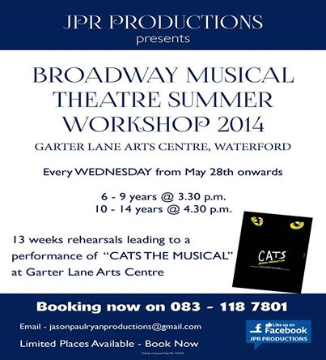](https://www.facebook.com/JPRProductionsIreland/photos/a.533853786642748.131617.533843223310471/828846013810189/?type=1&relevant_count=1)

E:[jasonpaulryanproductions@gmail.com](mailto:jasonpaulryanproductions@gmail.com)

Book now on 083 – 118 7801

**___________________________________________________________________________**

**SPRING POETRY WORKSHOPS AT GALWAY ARTS CENTRE**

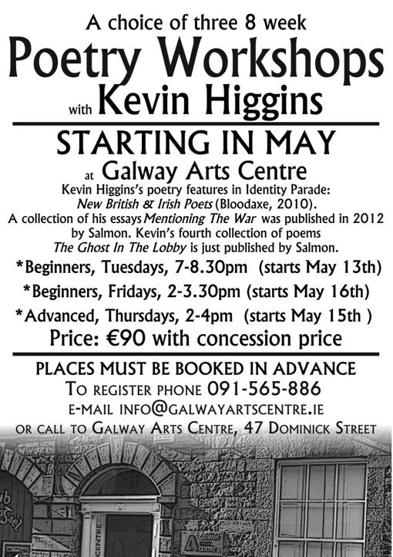

**Places must be paid for in advance.** To reserve a place contact reception at Galway Arts Centre, 47 Dominick Street, phone 091 565886 or email [info@galwayartscentre.ie](mailto:info@galwayartscentre.ie)

**___________________________________________________________________________**

**Training Programmes with Irish Times Training**

[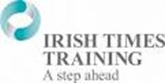](https://www.google.ie/url?q=http://claremulliganconsulting.ie/irish-times-training/&sa=U&ei=lCZyU4SmAciJ7AaS2YHgBA&ved=0CCwQ9QEwAA&usg=AFQjCNHINwmEOvQqShA4rNf7KV5-cbxBMQ)  
  
Business to Arts Affiliates are eligible for discounts of up to 70% on programmes delivered by Irish Times Training.  
   
Popular courses include:

* [Assertiveness Skills](http://cts.vresp.com/c/?BusinesstoArts/a038446613/608128ad7e/ad7bf14cf3) **26/27 May, 10/11 Sept**, **€625** reduced to **€250**
* [Dealing with the Media](http://cts.vresp.com/c/?BusinesstoArts/a038446613/608128ad7e/56e43582bb) **25 Sept, €475** reduced to **€250**
* [Influencing & Persuading](http://cts.vresp.com/c/?BusinesstoArts/a038446613/608128ad7e/0cf23f978d), **18 September**, **€395** reduced to **€250**
* [Minute Taking](http://cts.vresp.com/c/?BusinesstoArts/a038446613/608128ad7e/879c7d834a) **27 May, 26 June**, **€425** reduced to **€250**
* [Presentation Skills](http://cts.vresp.com/c/?BusinesstoArts/a038446613/608128ad7e/c684ca67d3) **4/5 Sept, €625** reduced to **€250**
* [Time Management](http://cts.vresp.com/c/?BusinesstoArts/a038446613/608128ad7e/f09774d96f) **25 June, €425** reduced to **€250**
* [Negotiation Skills](http://cts.vresp.com/c/?BusinesstoArts/a038446613/608128ad7e/0b7a42b6d4) **25/26 June, €650** reduced to **€250**
* [Finance for the non-Financial Manager](http://cts.vresp.com/c/?BusinesstoArts/a038446613/608128ad7e/3bdbdcc51d) **19/20 May, 30 June/1July, €750** reduced to **€250**
* [Digital Marketing](http://cts.vresp.com/c/?BusinesstoArts/a038446613/608128ad7e/0a0b0f3393) **21 May-4 June** (3 days), **€575** reduced to **€500**

Check the [Irish Times Training site](http://cts.vresp.com/c/?BusinesstoArts/a038446613/608128ad7e/1d2f70134a) for the complete list of courses. Discounts can only be secured for Business to Arts affiliates.  
Email [Rowena](mailto:rowena@businesstoarts.ie?subject=Training%20Booking) if you would like to book a place.

**___________________________________________________________________________**

**Call for Submissions / Residencies**

**___________________________________________________________________________**

# 4-Week Creative Residency in Russia for Dancers, Actors and Contemporary Circus Performers – Sept/Oct

# http://www.stagedirectorslab.org/_/rsrc/1397832402256/4weekresidency/linestagelab3.jpg

**The project mission is to create the “live creation platform” and the fascinating encounter of artists from diverse artistic backgrounds and techniques in multicultural and multilingual artistic environment.** The programme includes practical training, rehearsals and the intensive creative process on the way to the performance/work-in-progress.

For programme and application details, please visit [www.stagedirectorslab.org/4weekresidency](http://www.stagedirectorslab.org/4weekresidency)

**___________________________________________________________________________**

[**GMIT Centre for Creative Arts and Media: Summer Residency Programme**](http://visualartists.ie/jobs-ops/residencies-studio-exchanges/gmit-centre-creative-arts-media-summer-residency-programme/)

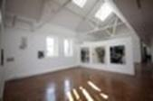

GMIT’s Centre for Creative Arts and Media (CCAM) is delighted to announce a new residency programme designed to support the work of arts practitioners who are interested in developing practice and research in Galway City and the West of Ireland during the summer months of 2014.

All submissions must be sent via email to the following address: [ccam@gmit.ie](http://kk-moss/Sites/arts_office/Shared%20Documents/Julianne%20Morgan/E-bulletin/16th%20May%20e-bulletin/ccam@gmit.ie)

* All applicants will **be notified by May 25th**
* **The residency will commence on June 16th**
* A Studio induction will take place on the 16th of June
* Unfortunately we will not be in a position to give feedback on applications or proposals.
* Email: [ccam@gmit.ie](http://kk-moss/Sites/arts_office/Shared%20Documents/Julianne%20Morgan/E-bulletin/16th%20May%20e-bulletin/ccam@gmit.ie)  
  [www.gmit.ie](http://www.gmit.ie/)
* More info at <https://www.gmit.ie/sites/default/files/public/creative-arts-and-media/docs/residency.pdf>

**___________________________________________________________________________**

# WIS Residencies

# [Poetry Ireland Logo](http://www.poetryireland.ie/index.php)

# The aim of the Writers in Schools Residencies is to develop the work already being carried out through [Writers in Schools Scheme](http://www.poetryireland.ie/education/writers-in-schools.html) one-off visits. The residencies involve a short residency by a writer to a school, working closely with one teacher and with the same class or group of not more than 30 students.

### [CLICK HERE TO DOWNLOAD THE WRITERS IN RESIDENCE APPLICATION FORM](http://www.poetryireland.ie/downloads/WIRApp06.doc)

Find out more by contacting us at:   
E [education@poetryireland.ie](mailto:education@poetryireland.ie)

W: <http://www.poetryireland.ie/education/wis-residencies.html>  
T 01 6789 022

**___________________________________________________________________________**

**A4 New Studios and Gallery | Call for Members**

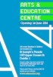

Our new studio is located on St Joseph’s Parade, off Upper Dorset Street, just 5 minutes from the top of O’Connell Street.

Membership starts at **€50 per month** allowing you 24/7 access to:

* Shared Studios & Desk space
* Electronics Area
* Darkroom
* Screen-printing Facilities
* Workshop & Tools
* If you are interested in becoming a member please fill out our membership form on our website.
* [www.a4sounds.org/join-us/](http://a4sounds.org/join-us/)

**___________________________________________________________________________**

**Open Call for Proposals TULCA 2014**

We are delighted to invite artists to submit their work for consideration for this year’s Festival, November 7 - 23 | 2014



TULCA is a multi-venue, artist-centered Festival of Contemporary Visual Arts taking place in Galway city and county since 2002. TULCA is now accepting submissions from artists to exhibit in 2014. This open-call opportunity is open to Irish and international artists working in any visual art practice and in design (graphic, furniture, textile and domestic scale industrial design), architecture, crafts, web-based work and social media as art form.

Details of curators statement and how to submit a proposal: [HERE](http://www.tulcafestival.com/open-call-proposals-tulca-2014/)

TULCA 2014 Deadline: **Thursday June 12th at 12.00pm**

Don't forget to join our mailing list [here](http://www.tulcafestival.com/mailing-list/)

**___________________________________________________________________________**

[**Opportunities at Hive Emerging | Become a Hive Artist**](http://visualartists.ie/jobs-ops/opportunities-ireland/opportunities-hive-emerging-become-hive-artist/)



The following opportunities are being made available this month.

• Studios Available

This May Hive is extending the opportunity to become a new studio member with the collective.  Applicants can email [info@hiveemerging.com](http://kk-moss/Sites/arts_office/Shared%20Documents/Julianne%20Morgan/E-bulletin/16th%20May%20e-bulletin/info@hiveemerging.com) (RE: studio) for further details.

• Join the Hive Team

The gallery have positions now available within our core staff, volunteer staff & board of directors. Applicants can email [info@hiveemerging.com](http://kk-moss/Sites/arts_office/Shared%20Documents/Julianne%20Morgan/E-bulletin/16th%20May%20e-bulletin/info@hiveemerging.com) (RE: team) for further details.

• Join the Hive Workshop

The gallery is now welcoming submissions from creative practitioners to take part in the establishment of the galleries workshop program. Applicants can email [info@hiveemerging.com](http://kk-moss/Sites/arts_office/Shared%20Documents/Julianne%20Morgan/E-bulletin/16th%20May%20e-bulletin/info@hiveemerging.com) (RE: workshop) for further details.

**Deadline for applications is Saturday May 24th.** New Artists will be announced May 31st.

W: [www.hiveemerging.com](http://hiveemerging.com/)

**___________________________________________________________________________**

**Life Imitating Art – call for submissions**

**[](http://www.voluntaryarts.org/wp-content/uploads/2014/05/life-of-pi.jpg)**

Oscar Wilde once famously said “Life Imitates art far more than art imitates life”. Voluntary Arts, in partnership with Ballymena – the Creative Borough, are looking to test that theory with a fun new campaign, Life Imitating Art.

This interactive Facebook campaign encourages people from right across the UK and R. Ireland to send in pictures of themselves imitating a piece of art. The campaign will be run right across the UK and Ireland during May with the winners announced at the end of the month.

Read more at <http://miniurl.com/1qapq>

**___________________________________________________________________________**

**Cork Literary Review Poetry Manuscript Competition 2014**

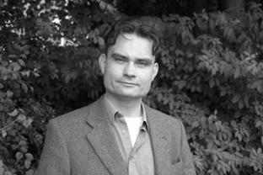

The judge for the Cork Literary Review Poetry Manuscript Competition for 2014 will be Poet Joseph Woods.

The prize includes the publication of a first poetry collection by the winning author and twenty free copies of the book. The overall competition winner and two runners-up will also be featured in the next edition of the prestigious Cork Literary Review.

**The closing date for the competition is 5.30pm on 21st July 2014.**

[Entry-form-2014](https://onedrive.live.com/view.aspx?cid=03A0248AD4FCB274&resid=3A0248AD4FCB274%21159&app=Word&wdo=1)

Further details [here](http://r20.rs6.net/tn.jsp?f=001MnTl3_QjuyL5B-aRjlhINk4tWqnUmBUE1hKqsPl_co2Wy2Tq0j9fT9kr_lDPKgSpdsZKxKAWE5QeWxClFEr79VEQ7TkARm9n7fOfgfIfYCiOQg2QOWsnf-BxPPrLlRru0PiiuL4pmAvJqy3hNvbInG3jitZjXSxzJsaQNDDya3skC5mZZ3h02h4dLH2pKCZKlnnmqZqlD1GkAageIzs4TkJDvQzOGeoD&c=Br_jK3bZcwm-kLzEj66RW03Y6BZS-3ersWg_2udNhghcbW3FLqZMCA==&ch=vIpKN6eDQRX6_DUxb6g5Gci6lzfpxX_qfvqRLoMOB4xjPpSt4OFb_A==).

**___________________________________________________________________________**

**While There's Still Time Competition**



Our new writing competition, While There’s Still Time, is aimed at generating shared experiences that will help more people set about putting things right, planning their future and getting the best from the rest of their life.

Genre: Prose, poetry. (Themed; see website for full details). Word Count: Maximum 2,500 words of prose or 40 lines of poetry. Entry Fee: Free. Prize: **1st prize - £200**, **2nd prize -** **£100**, **3rd prize -** **£50**, plus highly commended certificates. Some entries will, subject to the authors' agreement, be used to promote the Dying Matters Coalition and will feature on Dying Matters' website. **Deadline: 30th June**. [Link here](http://r20.rs6.net/tn.jsp?f=001MnTl3_QjuyL5B-aRjlhINk4tWqnUmBUE1hKqsPl_co2Wy2Tq0j9fTxSKAtWoKE6J8c8D0bgBQ7YdiXP7mqIQ83pXfoisPgrNG6BHQv5tA_aRzt42Emy92kaTAdBMDTvld5q3ty6NZcx6-sPBaDkgxIoJy9YpeRex25EtgO-Rf9mRFrfqRQukew==&c=Br_jK3bZcwm-kLzEj66RW03Y6BZS-3ersWg_2udNhghcbW3FLqZMCA==&ch=vIpKN6eDQRX6_DUxb6g5Gci6lzfpxX_qfvqRLoMOB4xjPpSt4OFb_A==).

**___________________________________________________________________________**

**Baby BEEF Independent Art Press | Call for Submissions**



We started Baby BEEF in 2006 as a contributor based zine of art, poetry, stories, photography and articles. We have decided to make Baby BEEF Issue 4 this summer and launch it at this year’s 4th Annual Dublin Zine Fair in August.

We are looking of submissions of art, poetry, stories and articles. We celebrate the handmade and love anything analogue, so we are not looking for digital artwork. Pretty much anything goes. If you have any questions let us know.

Submit to: [babybeefheart@hotmail.com](http://kk-moss/Sites/arts_office/Shared%20Documents/Julianne%20Morgan/E-bulletin/16th%20May%20e-bulletin/babybeefheart@hotmail.com)

More info about our publications: [www.babybeefartpress.com](http://www.babybeefartpress.com)

**___________________________________________________________________________**

**Love after 65 Springs – call for couples to pose for portraits – July/August**

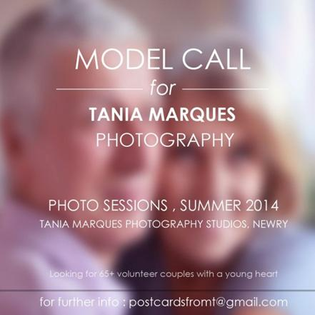

If you´re interested please email me to [postcardsfromt@gmail.com](http://kk-moss/Sites/arts_office/Shared%20Documents/Julianne%20Morgan/E-bulletin/16th%20May%20e-bulletin/postcardsfromt@gmail.com)

W: <http://miniurl.com/Keoc>

**___________________________________________________________________________**

**National Sculpture Factory... New Opportunity Im/Plants**



The National Sculpture Factory announces its new programmatic strand for 2014/15, *Im/plants*, open to all international artists.

*Im/Plants* proposes a programme of seasonal *implantations* (insertions) into the National Sculpture Factory. This project is open to Irish and international artists, curators, independent art groups, individual cultural and spatial practitioners, and collectives across all art disciplines. Each *implant* is of a 3-month duration and is programmed to happen seasonally. It is self-directing and self-sufficient, with an overall stipend of **€3,000**.

**All applications must reach the National Sculpture Factory by 12 Noon, Monday 9th June 2014.**

For the full details on applications please visit <http://nationalsculpturefactory.com/current/implants/>

**___________________________________________________________________________**

[**RHA School | Summer Self-directed Life Drawing Sessions**](http://visualartists.ie/jobs-ops/courses/rha-school-summer-self-directed-life-drawing-sessions/) **– Call for applications**



RHA School, 15 Ely Place, Dublin 2

The RHA School is delighted to announce an open call to artists to apply for places on the weekly summer life-drawing sessions. Sessions are being offered on a weekly basis on Thursdays over four weeks, commencing on **Thursday, 10th July.**

**The deadline for applications is Friday 6th June 2014**

Please note that application is only available on-line.

Any queries should be forwarded to the Academy Co-ordinator, Fernando Sanchez.

Phone: 01 6612558 or Email: [fernando@rhagallery.ie](http://kk-moss/Sites/arts_office/Shared%20Documents/Julianne%20Morgan/E-bulletin/16th%20May%20e-bulletin/fernando@rhagallery.ie)

Read more at <http://miniurl.com/1qau8>

**___________________________________________________________________________**

**7th Annual 126 Members’ Show | Open Call**



Curated BY Paul McAree  
126, Artist-run Gallery, 4 Commerce House, Flood Street, Galway City

As part of our continued commitment to support our membership, 126 is delighted to announce a call out for its 7th Annual Members’ Show. This year, with generous support from the Galway Arts Festival, we would like to present the work of our members to the international audience that visit the festival from 14th – 27th of July. To develop this exhibition, we are delighted to announce Paul McAree as curator. McAree is founder of FLOOD, Dublin, a contemporary art project in Dublin city.

**Closing Date for Submissions by email, June 6th, 2014 at 4pm**

For more information visit: [www.126.ie/#opencall](http://www.126.ie/#opencall)

**___________________________________________________________________________**

**Public Art Commission: The Giant’s Lair, Ireland Largest Children’s Story Park**



CALL FOR ARTISTS:

The Giant’s Lair, Ireland’s largest Children’s Story Park.

Located at: Slieve Gullion, Forest Park, Newry

Sticky Fingers, Ireland’s leading arts organisation for young children in collaboration with Newry and Mourne District Council, is seeking to commission a range of high quality, permanent, innovative and original works inspired by the legends, folklore and children’s interpretations of the mythical history of the Slieve Gullion area.

Sticky Fingers are currently inviting expressions of interest from visual artists and landscape artists working in the public realm for this exciting art project.

Budget range from **£30,000 for each large-scale artwork and £6,000 for each small-scale art work.**

For further details on the application process email: [grainne@stickyfingersarts.co.uk](http://kk-moss/Sites/arts_office/Shared%20Documents/Julianne%20Morgan/E-bulletin/16th%20May%20e-bulletin/grainne@stickyfingersarts.co.uk).

Deadline for stage one applications is **30th June 2014.**

Read more at <http://miniurl.com/2M6kh>

**___________________________________________________________________________**

**6th Brandenburg Biennial**

**[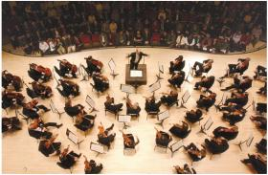](http://mediad.publicbroadcasting.net/p/wabe/files/201209/Orchestra_overhead.jpg)**

Deadline: **24th May, 2014**

The Association of Friends of the Brandenburg Symphony Orchestra (FBS e.V.) announces the sixth edition of its competition for composers of symphonic music. The competition is international and open to all age groups.  
  
Web: [fbsym.de/index.php?id=74](http://fbsym.de/index.php?id=74) **cid:image163.gif@01CF70F3.85D33910**

**___________________________________________________________________________**

**Young Film Maker Competition**

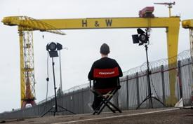

Filmmakers aged 25 and under, from the UK and Ireland, are invited to submit their short films to the annual Cinemagic Young Filmmaker Competition which honours the best of young filmmaking talent across different categories.

To enter, just send a DVD copy of your film with a completed [entry form](http://cinemagic.org.uk/downloads/Young_Filmmaker_2014_-_Entry_Form.pdf) before the competition deadline- **19th September 2014**

Films should be no longer than 10 minutes

Click [here](http://cinemagic.org.uk/downloads/Young_Filmmaker_2014_Regulations.pdf) for Regulations

W: [http://tinyurl.com/ljqynv9](http://tinyurl.com/ljqynv9%20)

**___________________________________________________________________________**

**Invitation to Tender for Public Art Work under the Per Cent for Art Scheme**

[](https://www.google.ie/url?q=http://hospicefoundation.ie/the-irish-hospice-foundation-seeks-clarity-about-specialist-palliative-care-budget/hse-logo-2/&sa=U&ei=kXt0U9mlHOjm7AawsoCoBg&ved=0CCwQ9QEwAA&usg=AFQjCNHOEYct2sNz_tcbYhSY9iB7hg2dHw)

As part of the New Ward Extension at Ennistymon Community Hospital, Ennistymon, Co. Clare, the HSE is now inviting Artists to tender for the provision of original art work(s) for display, under the terms of the Government ”Per Cent for Art Scheme”. **The available funding is €7,300.**

The deadline for receipt of proposals is by **4pm on Tuesday 10th June 2014.** Given the short timeframe for this Per Cent for Art Scheme, artwork already completed will be considered for purchase if it fits with the project requirements as outlined in the brief.

The detailed Invitation to Tender document is available here [Per Cent for Art Brief for Ennistymon Ward Extension R2 May 2014](http://lists.visualartists.ie/lt.php?c=1153&m=4193&nl=1&s=e97e60e0a85e4e4156f0ad241cfbea58&lid=87279&l=-http--visualartists.ie/wp-content/uploads/2014/05/Per-Cent-for-Art-Brief-for-Ennistymon-Ward-Extension-R2-May-2014.pdf) with plans and photos here: [Ennistymon-Community-Hospital-Appendix-2-Art-Plan-Photos1.pdf](http://lists.visualartists.ie/lt.php?c=1153&m=4193&nl=1&s=e97e60e0a85e4e4156f0ad241cfbea58&lid=87280&l=-http--visualartists.ie/wp-content/uploads/2014/05/Ennistymon-Community-Hospital-Appendix-2-Art-Plan-Photos1.pdf)

**___________________________________________________________________________**

**Awards / Bursaries / Schemes**

**RHA: The Elizabeth Fitzpatrick Travel Bursary 2014**

rha2

The RHA is delighted to present an open call for submissions to the Elizabeth Fitzpatrick Travel Bursary 2014. The Bursary of **€2,500** is awarded to enable Irish artists to further their studies abroad.

Applications forms and further information on the award conditions are available on the RHA Website: [http://www.rhagallery.ie/about/awards/](http://www.rhagallery.ie/about/awards)

**The deadline for receipt of completed application forms is Friday 6th of June 2014.**

For further information on the Elizabeth Fitzpatrick Travel bursary contact Fernando Sanchez, Academy Coordinator, phone 01 6612558, email [fernando@rhagallery.ie](http://kk-moss/Sites/arts_office/Shared%20Documents/Julianne%20Morgan/E-bulletin/16th%20May%20e-bulletin/fernando@rhagallery.ie)

**___________________________________________________________________________**

**BAI – Sound & Vision II Funding Scheme**

[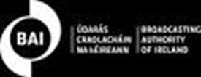](https://www.google.ie/url?q=http://www.bai.ie/&sa=U&ei=CzZqU9CxLcm07QaCmYCYCw&ved=0CDYQ9QEwBQ&usg=AFQjCNGGCOZ026LcoOjYpraeNwy3k9PM9w)

The Broadcasting Funding Scheme (Sound & Vision II) was established to provide funding in support of high quality programmes on Irish culture, heritage and experience, and programmes to improve adult or media literacy.

### Eligible Funding

The Scheme can fund a maximum of 95% of the costs in the eligible budget.

### How to Apply

Download the application form and full guidelines [from the BAI website](http://www.bai.ie/?page_id=92).

**Deadline: 12th June**

See more at: <http://miniurl.com/1qapr>

**___________________________________________________________________________**

**The Arts Council – Funding**

# Splanc! Arts Documentary Scheme

# cid:image170.jpg@01CF70F3.85D33910[cid:image171.gif@01CF70F3.85D33910cid:image171.gif@01CF70F3.85D33910cid:image171.gif@01CF70F3.85D33910](http://www.voluntaryarts.org/)

**The Arts Council and TG4 invite submissions for the 8th season of Splanc!**

This year the scheme aims to support ambitious landmark factual films on a contemporary artistic theme that are notably creative in their execution. **A total fund of €120,000** is available and will support two hour-long films or one feature length film.

**Deadline for receipt of submissions is 1 pm, Friday, 30th May, 2014.**

Read more at: [http://tinyurl.com/nczfyk3](http://tinyurl.com/nczfyk3%20)

Artist in the community scheme

Twice yearly, the Arts Council offers grants to enable artists and communities of place/or interest to work together on projects.

There are two phases to the scheme.

**Phase One**

[Research & Development](http://newsletter.artscouncil.ie/1rlddxfaj7v14rbsgtdsq9?a=6&p=47027345&t=17684704)  
[Research & Development/Mentoring](http://newsletter.artscouncil.ie/2x9bljt4rjn14rbsgtdsq9?a=6&p=47027345&t=17684704)

**Phase Two**

[Project Realisation](http://newsletter.artscouncil.ie/1my9i3o2ve114rbsgtdsq9?a=6&p=47027345&t=17684704),

Deadline: **June 23rd**

Full details on the application criteria on the Create website: <http://tinyurl.com/ms68f5e>

Engaging with Architecture Scheme

Maximum awarded: **€20000**

The purpose of the scheme is to support ambitious, innovative and creative, high-quality initiatives that specifically aim to enhance and extend the public’s experience of and engagement with architecture.

Deadline: **Thursday, 12th June, 2014 at 5.30pm and projects must take place before 24th April, 2015.**

More info about the above funding and contact details at <http://www.artscouncil.ie/en/funding_deadlines.aspx>

**___________________________________________________________________________**

**The Arts Council - Awards**

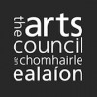

**Travel & training award**

Closing date: Ongoing

Maximum awarded: **€8000**

The objective of the travel and training outbound award is to support individuals who wish to avail of training and other professional development opportunities abroad (outside the Island of Ireland).

Download the [2014 Travel and training guidelines](http://www.artscouncil.ie/GetAttachment.aspx?id=40549163-3f5f-45c3-b9fe-f98b545d1adc)(0.15 MB, MS Word)

Read more at <http://miniurl.com/Kd1r>

Deis Award

The deadline for the next round of the Arts Council's Deis Award is **Thursday 5th June, 2014 at 5.30pm.**

Deis is aimed at encouraging and facilitating the traditional arts community to seek funding from the Arts Council for a range of projects.

You can download the guidelines by clicking on the link below:

* [Guidelines Deis R2 2014](http://www.artscouncil.ie/GetAttachment.aspx?id=3c0b8670-df52-413d-b647-f9afce0f6790)(0.09 MB, MS Word)

Read more at <http://www.artscouncil.ie/en/funding_deadlines.aspx>

Bursary Awards

The deadline for the next round of the Arts Council’s Bursary Awards is **Thursday, 17th July 2014 at 5.30pm.** The window for making an application opens on **Tuesday, 17th June 2014.**

The following awards are available:

• YPCE Bursary Award

• Traditional Arts Bursary Award

• Literature Bursary Award (English Language)

• Visual Arts Bursary Award

The Arts Council provides Bursary Awards in order to assist individual artists in the development of their art practice.

View all at <http://www.artscouncil.ie/en/funding_deadlines.aspx>

**___________________________________________________________________________**

**KBC Bright Ideas Fund - deadline extended to 30th May**

[](http://www.kbc.ie/)  
The KBC Bank Ireland  inaugural ‘KBC Bright Ideas’ community initiative is aimed at individuals and organisations in Dublin, Limerick, Galway and Cork who want to transform, improve or revolutionise their communities through creative ideas. An overall pool of **€20,000** is available per hub city.  
   
**The closing date has been extended until 30th May**, and entries are accepted through an online application form that requires entrants to submit their innovative ideas, explain why the idea would transform their community and describe how the money will be invested. More details [here](http://cts.vresp.com/c/?BusinesstoArts/a038446613/608128ad7e/4430395082/i=29965&gc=3&p=104&n=135).

**___________________________________________________________________________**

**Fundit.ie Update**

[Fundit.ie](http://fundit.ie/)  
   
[Fund it](http://cts.vresp.com/c/?BusinesstoArts/a038446613/608128ad7e/e285aeb424) has provided a platform for 633 projects across the creative industries to be funded by their fans, followers, families and friends.  
   
46,000 people from all over the world have pledged money to Irish creative ideas and €2.3m has been paid out to successful projects. It’s worth considering if Fund it should be part of your broad funding landscape.

**___________________________________________________________________________**

**The Kieran Meagher Legacy Award for Visual Artists**



Kieran Meagher was an artist as well as a well-respected educator and academic whose passing sadly occurred in September 2013.

**Project Description:**

The award will be presented to an artist from, trained or based in Limerick. The award will allow them to investigate and develop a new body of work and support their practice throughout 2014 and beyond.

**This bursary will award one artist €10,000 and is kindly supported by Limerick City of Culture 2014.**

**Closing date** **for receipt of applications is Friday 30th May at 3pm.**

Applications must be submitted to Culture House, 2 Pery Square marked Kieran Meagher Legacy Award.

**More info** and application form can be found here: <http://limerickcityofculture.ie/content/kieran-meagher-legacy-award>

**___________________________________________________________________________**

**RDS Student Art Awards| Call for Entries**



The Royal Dublin Society (RDS) is calling for entries for its 2014 RDS Student Art Awards. Enter online at [www.rds.ie/arts](http://lists.visualartists.ie/lt.php?c=1132&m=4172&nl=1&s=e784eec6bf8bb9680747b324b9c9eee1&lid=85353&l=-http--www.rds.ie/arts)

The RDS Student Art Awards has an annual prize fund in excess of **€17,000**. The RDS Student Art Awards aims to provide a platform that supports the transition from student to emerging artist through the [Awards](http://www.rds.ie/index.jsp?a=968&n=177&p=211) and Exhibition.

Application forms are accessible online at [www.rds.ie./arts](http://lists.visualartists.ie/lt.php?c=1132&m=4172&nl=1&s=e784eec6bf8bb9680747b324b9c9eee1&lid=85354&l=-http--www.rds.ie./arts) until the **closing date deadline of 4.00pm, June 18th.**

**___________________________________________________________________________**

# Ulster Bank Community Impact Fund Opens for 2014

[Contact Us](http://www.foundation.ie/contact-us/contact)

# Our Grants

Developed through a partnership between Ulster Bank, The Community Foundation for Ireland and The Community Foundation for Northern Ireland, the Ulster Bank Community Impact Fund is now accepting applications from all non-profit, voluntary and community based organisations. TheUlster Bank Community Impact Fund is a €290,000 fundestablished to give local communities a welcome boost by providing grants to support their work in enterprise creation, financial education and employability initiatives throughout the Island of Ireland.

**Deadline for applications: 23rd May at 5pm**

[Download](http://www.foundation.ie/images/uploads/file/grants/Revised_17_14_Ulster%20Bank%20Community%20Impact%20Fund%20Criteria%20Application%20form%20Ireland%20-%20Copy.doc) the Criteria and Application form

More info at [http://tinyurl.com/plwsedt](http://tinyurl.com/plwsedt%20)

**___________________________________________________________________________**

# Arts and Older People Programme 2013 – 2016 – closing 19/05/14

# [http://www.steventunley.com/img/funders/ac_funder.gif](http://www.artscouncil-ni.org/)

## [Arts and Older People Programme 2013/2016 – closing 19/05/14](http://comartspartner.us4.list-manage.com/track/click?u=b8a8a675fc3c8c08286c7e4ee&id=c3b61d0571&e=7e0fff4d77)

This scheme is open. Deadline for applications: **Thursday 19th June 2014 at 3pm**. The Arts and Older People Programme 2013 – 2016 aims to strengthen the voice of older people and promote positive mental health and emotional well-being through the arts. Who can apply? The programme is aimed at constituted community and voluntary groups who..... [read more>>](http://comartspartner.us4.list-manage1.com/track/click?u=b8a8a675fc3c8c08286c7e4ee&id=124532101a&e=7e0fff4d77)

**___________________________________________________________________________**

# ACNI – Travel Awards – ongoing

# [http://www.steventunley.com/img/funders/ac_funder.gif](http://www.artscouncil-ni.org/)

Awards to enable individual artists and arts administrators from Northern Ireland to develop their skills and widen their expertise. Size of award is dependent on destination. Full details in Guidance Notes – available along with application forms at the link below.

Deadline for applications: **Ongoing**

[www.artscouncil-ni.org/funding/scheme/travel-awards](http://www.artscouncil-ni.org/funding/scheme/travel-awards)

# ___________________________________________________________________________

**5,000 Allianz Community Art Prize - closing date 21st May**

[](http://www.businesstoarts.ie/)  
For the third year running, as part of the Allianz Business to Arts Awards 2014, the Allianz Staff will invest €5,000 in a community-based arts initiative through the Allianz Community Art Prize. Staff members nominate projects with a cultural and community emphasis – something they, a client, a family member or friend are passionate about.

# Contact [Business to Arts](mailto:awards@businesstoarts.ie?subject=Allianz%20Community%20Art%20Prize%20Query) to request an application form.

# Forms should be submitted by ****21st May**** in soft copy along with 800 words on the project. ___________________________________________________________________________

# ****House and Home MAKE IT Award 2014****

# House and Home MAKE IT Awards 2014 House and Home MAKE IT Award in association with the Design & Crafts Council of Ireland (DCCoI) and Fund it, is an open call to Irish designers / makers to design a 'consumer focused' household product for market with a recommended retail price between €20 -€200. The award is open to all, including professionals, graduates and students in the Irish design and craft industry. The prize package aims to support the winning product in getting to market. Click [here](http://cts.vresp.com/c/?BusinesstoArts/a038446613/608128ad7e/94cd6ac155) for entry details.

# Closing date: 15th August. ___________________________________________________________________________

# Arts and Disability Connect scheme 2014

## [cid:image185.gif@01CF70F3.85D33910](http://www.adiarts.ie/)

# **Arts & Disability Ireland and Arts Council announce Arts and Disability Connect (ADC) a new scheme open to artists with disabilities working in any artform.**This scheme is designed to support artists with disabilities to make new and ambitious work.

**Arts and Disability Connect New Work**  
2 awards of up to **€8,000 each**

**Arts and Disability Connect Mentoring**                                             
3 awards of up to **€2,000 each**

**Arts and Disability Connect Training**                                                     
3 awards of up to **€1,000 each**

All application forms, guidelines and information documents can be downloaded <http://tinyurl.com/oagpchq>

A completed application form along with all supporting material must be sent to [info@adiarts.ie](http://kk-moss/Sites/arts_office/Shared%20Documents/Julianne%20Morgan/E-bulletin/16th%20May/info@adiarts.ie%20) using WeTransfer by **5pm on** **12th June 2014.**

**Further information:**Contact Arts & Disability Ireland at 01 850 9002 or email [info@adiarts.ie](http://kk-moss/Sites/arts_office/Shared%20Documents/Julianne%20Morgan/E-bulletin/16th%20May/info@adiarts.ie )

# ___________________________________________________________________________

# Art Universe – Scholarship Opportunities – International Physical Theatre Laboratory 2014

**[](https://picasaweb.google.com/globtheatre)**

**“ArtUniverse” in partnership with the International University ”Global Theatre Experience” (IUGTE)** have announced several partial scholarships for professional dancers, choreographers, actors and circus performers.

International Physical Theatre Laboratory 2014

**Project Dates and Location:**

**July 7-12** – Styria, Austria [View Post](http://comartspartner.org/news/opportunities/art-universe-scholarship-opportunities-international-physical-theatre-laboratory-2014/)  
Each scholarship grant covers up to €400 (four hundred) of the total participation fee.

**December 15-22** – Tuscany, Italy  
Each scholarship grant covers up to €300.00 (three hundred) of the total participation fee.

More info at <http://miniurl.com/Keod>

**___________________________________________________________________________**

**Bord Gáis Energy Irish Book Awards**



**Submissions are now open!**

Publishers please note that online submissions for the 2014 Awards are now being accepted. Make your submissions [here](http://www.irishbookawards.ie/submissions-2013/)**.** The eligibility period for title submissions for 2014 covers books published between 1st November 2013 and 31st October 2014. Please review the [Eligibility Guidelines](http://www.irishbookawards.ie/eligibility-guidelines/) before submitting.  Closing date for submissions is September 1st 2014.

The Shortlist Announcement will be on Thursday 30th October.

W: <http://www.irishbookawards.ie/>

**___________________________________________________________________________**

**Of Interest**

**___________________________________________________________________________**

## Borris House Festival of Writing & Ideas

## [http://festivalofwritingandideas.com/img/biglogo.png](http://festivalofwritingandideas.com/home)The weekend of 14th and 15th June 2014 will bring together some of the most intriguing international minds – novelists, journalists, film-makers, poets, theatre directors, war correspondents, biographers, artists and political commentators – for a weekend of stimulating dialogue and discussion.

## More info at <http://festivalofwritingandideas.com/>

**___________________________________________________________________________**

**Electric Picnic Trailer Park Winners Unveiled!**

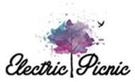

And the WINNERS are:

The Old Octopus Medicine Show by Seamus Scullion; The Incredibly Mad De-Programming Machine by David Sumray; Caravan Club Extravaganza by Dermot Agnew; My Big Fat Redneck Wedding by Clement Wilson & Lucy Osborne; Steampunk Time Machine by Patsy Preston; The Milky Moon by Mark & Amelia O’Keeffe; StageCoach by Paul McCormack & Denis Walsh; Lord Ganesh’s Larder by Fiona Arakelian; An Impossible Space by Mark Cronin; The Listening Chamber by Harry Harris; Caravanaoke by Brian Connolly, Neil Conlan & Frank Gough; Betty Bang by Angi Dixon; MAKESHOP by The Science Gallery.

View winning entries at [www.electricpicnic.ie](http://lists.visualartists.ie/lt.php?c=1151&m=4191&nl=3&s=e97e60e0a85e4e4156f0ad241cfbea58&lid=86980&l=-http--www.electricpicnic.ie)

**___________________________________________________________________________**

# Eoin Colfer named as Laureate na nÓg



On Thursday 8th May 2014, novelist Eoin Colfer was announced as the third Laureate na nÓg, Ireland’s laureate for children’s literature, at a special event at the Arts Council of Ireland - An Comhairle Ealaion. Laureate na nÓg is an initiative of the Arts Council with the support of the Department of Children and Youth Affairs, Children’s Books Ireland, Poetry Ireland and the Arts Council of Northern Ireland.

|  |  |
| --- | --- |
| [Read more](https://s5.newzapp.co.uk/t/gtl_pg.aspx?LID=ODcxNjIxMCw1MjAyODQ4ODIsMTQ=) |  |

**___________________________________________________________________________**

**List Your Exhibitions, Events and Opportunities in the Visual Artists’ E-bulletin**



Visual Artists Ireland’s e-bulletin is a twice-weekly service providing the latest information on news, opportunities, exhibitions and events relating to the visual arts in Ireland

We do not charge for this service, we simply need you to send us your listings.

If you are not one of our regular advertisers or need a reminder on how to send us information, you can find out more on this service[here](http://lists.visualartists.ie/lt.php?c=1146&m=4186&nl=1&s=d3c261c0eeb6b48867f449d29e09414b&lid=86412&l=-http--visualartists.ie/publications/ebulletins/)To submit your information to us see[here](http://lists.visualartists.ie/lt.php?c=1146&m=4186&nl=1&s=d3c261c0eeb6b48867f449d29e09414b&lid=86327&l=-http--visualartists.ie/contact/eguidelines/)

If you have any questions email us at [listings@visualartists.ie](mailto:listings@visualartists.ie)

**___________________________________________________________________________**

**SATURDAY May Over The Edge Writers’ Gathering @ Charlie Byrne’s Bookshop: Tom Duddy, Cormac Culkeen, Billy Ramsell, Anna McCartty, Maeve O’Sullivan**

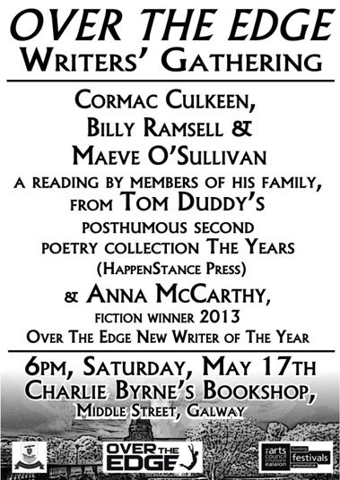

The May Over The Edge Writers’ Gathering presents readings by fiction writer Anna McCarthy, and poets Cormac Culkeen, Billy Ramsell & Maeve O’Sullivan. The evening will also see a reading, by members of his family, from Tom Duddy’s posthumously published second poetry collection: *The Years* (HappenStance Press, 2014).  The event will take place at Charlie Byrne’s Bookshop, Middle Street, Galway this **Saturday, May 17th, 6pm**. All are welcome. There is no cover charge.

For further information contact 087-6431748.

 Over The Edge acknowledges the ongoing financial support of the Arts Council and Galway City Council. <http://www.overtheedgeliteraryevents.blogspot.com/>

**___________________________________________________________________________**

# KFEST Music and Arts Festival 2014

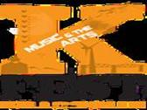

## Date: May 30th – June 2nd, 2014

## Location: Killorglin, Co. Kerry, Ireland

**75+ Artists, 25+ Galleries, 15+ Bands, 1 Town**

W: [http://www.kfest.ie/#](http://www.kfest.ie/%23)

**___________________________________________________________________________**

# Cinemagic - International Film and Television Festival for Young People

# [http://www.cinemagic.org.uk/images/made/images/uploads/Schools_Programme_Image_1_373_248.JPG](http://www.cinemagic.org.uk/educators)

# Cinemagic is an award winning festival that embraces the magic of film, television and digital technologies to educate, motivate and inspire young people through film screenings, industry workshops, practical masterclasses, filmmaking projects and outreach activities.

# Read more at <http://www.cinemagic.org.uk/>

**___________________________________________________________________________**

|  |
| --- |
| Re-Presenting Ireland 2014Re-Presenting Ireland Culture Ireland, Dance Ireland & Dublin Dance Festival  Be part of Ireland’s leading dance platform by booking your tickets for **Re-Presenting Ireland** now! Performances take place on **23, 24, 30 & 31ST May**. [READ MORE](http://danceireland.us5.list-manage1.com/track/click?u=5121d0fedd423c64bdbf0d66b&id=f9acf19603&e=1505fd3a45) |

***************************************************************************